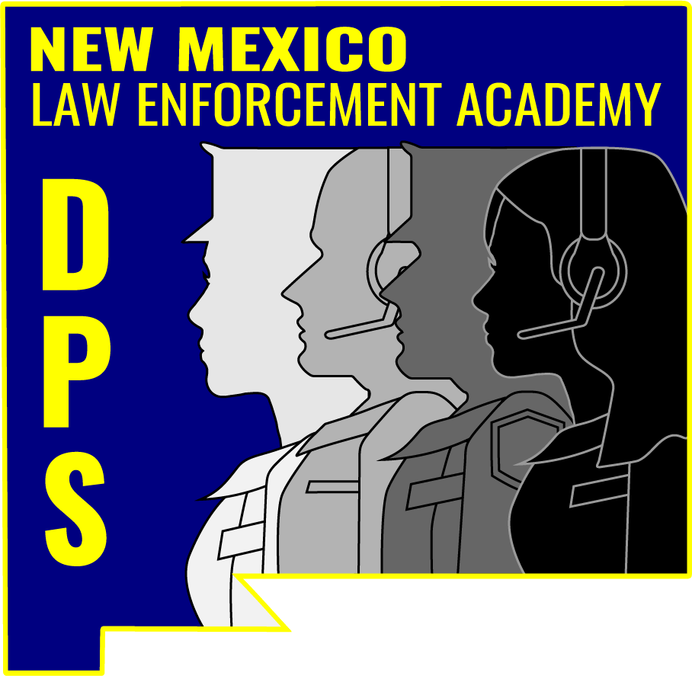
Racial Sensitivity

Version: 2026 NM260006

INSTRUCTOR LESSON

Version: 2026 NM260006
Lesson Purpose: The purpose of this lesson is to increase awareness and understanding of racial sensitivity by examining how implicit bias, cultural differences, and historical context can influence perceptions, communication, and decision-making during interactions with the public.

Learning Objectives: During this lesson, students will receive information and instruction on how to do the following:

1. Understand the role of racial sensitivity in building public trust.
2. Identify and address racial, implicit, and confirmation biases.
3. Recognize generational shifts in societal norms and their impact.
4. Learn traits of racially responsible and trusted police departments.
5. Apply strategies to improve community interactions and outcomes.
Hours: 1

Instructional Methods: Online In-Service Learning

Required Materials,
Aids & Equipment: Internet access, Log-in through Acadis

Handouts: N/A

Testing Requirements: End-of-topic test

References: APCO International. (n.d.). APCO International - Leaders in Public Safety Communications. https://www.apcointl.org/
Avoiding “profiling by proxy.” (2016, December 20). Vera Institute of Justice. https://www.vera.org/news/avoiding-profiling-by-proxy

Schlosser, L., PhD, ABPP, McCutcheon, J., PsyD, MSCP, ABPP, PLLC, Bricker, M., PhD, & Stewart, C., PsyD, ABPP. (n.d.). Assessing Bias and Intolerance in Police and Public Safety Personnel. IACP Police Chief Online. Retrieved January 30, 2026, from https://www.policechiefmagazine.org/assessing-bias-and-intolerance/

Walsh, C., & Walsh, C. (2024, January 11). Solving racial disparities in policing. Harvard Gazette. https://news.harvard.edu/gazette/story/2021/02/solving-racial-disparities-in-policing/
Weinstein, J., PhD. (2022). Building understanding and trust recommendations to improve Community-Police interactions. IACP Police Chief Online.

Video: Aldersgate Camp & Retreat Center. (2020, July 17). How are microaggressions like mosquitoes? [Video]. YouTube. https://www.youtube.com/watch?v=emz49wSnNcs

McCombs School of Business. (2018, December 18). In-group/Out-group | Ethics defined [Video]. YouTube. https://www.youtube.com/watch?v=AkYJOYrNiSw
McCombs School of Business. (2021, January 28). Confirmation bias | Ethics defined [Video]. YouTube. https://www.youtube.com/watch?v=7zoWTb3KP-k
McCombs School of Business. (2024, September 6). Implicit bias | Ethics defined [Video]. YouTube. https://www.youtube.com/watch?v=guqFrhtwdSA

Picture Alternatives. (2019, November 12). Our hidden biases [Video]. YouTube. https://www.youtube.com/watch?v=ZWgVs4qj1ho

The Science Lens. (2022, September 16). Confirmation Bias: Learn to overcome this common cognitive bias [Video]. YouTube. https://www.youtube.com/watch?v=rHgn2bRK7ms

[Authored / Revised /
Reviewed] By: NMLEA
2/2026

Instructor Notes

[List specific content designed exclusively for instructors to help them prepare for and deliver the lesson. This includes but is not limited to instructor credential requirements, skills testing protocols, and delivery strategies. The amount of content covered in this section will vary by lesson.]

1. Be familiar with Jim Crow laws

2. Be familiar with the Civil Rights movement

- Introduction

SLIDE: “Words to know”

Bias-free policing - Bias-free policing mandates that law enforcement treat all individuals fairly, equitably, and objectively, regardless of race, gender, sexual orientation, religion, or socioeconomic status.

Biased policing - Bias-based policing, also known as racial profiling, is the discriminatory practice of law enforcement focusing on individuals based on race, ethnicity, religion, gender, sexual orientation, or other perceived characteristics, rather than on actual behavior or evidence of criminal activity.

Community policing - Community policing is a proactive strategy focusing on building trust and collaborative partnerships between law enforcement and community members to identify, address, and prevent crime.

SLIDE: “Words to know”

Confirmation bias - Confirmation bias is the cognitive tendency to search for, interpret, favor, and recall information that confirms pre-existing beliefs while ignoring contrary evidence. This bias leads to flawed decision-making in the workplace, creates echo chambers in relationships, and causes skewed, one-sided perspectives in education and research.

Generational shifts - Generational shifts represent the ongoing, 20-year cycle of change in societal norms, technology adoption, and workplace values as new cohorts replace older ones.

Microaggressions - Microaggressions are everyday, often unintentional, verbal or non-verbal slights, insults, or indignities that communicate hostile or negative messages to marginalized groups.

SLIDE: “Words to know”

Racial bias - Racial bias is the unfair treatment, judgment, or assumption about individuals based on their race or ethnicity, operating through conscious prejudice or unconscious (implicit) stereotypes.

Racial sensitivity – Racial sensitivity is the awareness of how words, actions, and implicit biases impact people of different races and cultures, aiming to foster respect, empathy, and inclusion.

Restorative justice - Restorative justice (RJ) is a collaborative approach to crime and conflict that repairs harm by focusing on victim needs, offender accountability, and community involvement.

Body
- Racial Sensitivity and First Responders

SLIDE: Racial Sensitivity and First Responders

- What is Racial Sensitivity?
Understanding and responding to diverse cultural and racial backgrounds with respect, empathy, and fairness.

- Why does this matter?
Enhances trust, cooperation, and safety for both first responders and the communities they serve.

B. Historical Context and Harmful Behaviors in Law Enforcement

Slide: Historical Context and Harmful Behaviors in Law Enforcement

This training is necessary due to Historical Ideologies and Practices:

Discriminatory policies (for example, Jim Crow laws, racial profiling).
Historical mistrust due to over-policing and under-protecting minority communities and
High-profile incidents of excessive force.

Slide: The Need for Racial Sensitivity Training:

- Address generational trauma and perceptions.
- Foster fair and equitable treatment of all individuals

Slide: Harmful Behaviors and Language:

      - Behaviors: Racial profiling, over-policing specific communities, ignoring cultural norms.
      - Language: Stereotyping, derogatory comments, dismissive or minimizing statements.

C. Understanding Bias

Slide: Racial

Let's learn more about understanding Racial, implicit and confirmation bias.

Most people are familiar with the term racial bias, the unfair treatment, prejudice, or stereotyping of individuals based on their race, manifesting either consciously (explicit) or unconsciously (implicit). It shapes perceptions and behaviors, causing disparities in employment, education, healthcare, and justice systems. This systemic, structural, or individual issue often favors one group over another, perpetuating discrimination.

Let's take a look at “in-group” and “out-groups”.

Video: In Group/ Out Group (1:28)

Slide: Click to play the icon to show a 1:28 minute video, “In Group / Out Group” https://www.youtube.com/watch?v=AkYJOYrNiSw

Slide: What is Implicit Bias?

Implicit bias refers to unconscious attitudes, stereotypes, and unintentional actions that affect understanding and decisions, often contradicting one’s conscious values. These involuntary, internalized associations regarding race, gender, and other social categories can create disparities in healthcare, hiring, and policing. While generally harmful to equity, they can be managed through awareness and counter-stereotypical training.

Video: Implicit Bias (2:06)

Slide: Click to play the icon to show a 2:06 minute video, “Implicit Bias” https://www.youtube.com/watch?v=guqFrhtwdSA

Slide: Overcoming Confirmation Bias

    - Actively seek opposing views: Specifically search for evidence that contradicts your current hypothesis.
    - Practice critical thinking: Question your own assumptions and consider alternative explanations.
    - Involve others: Ask for feedback from people with different perspectives.
    - Slowing down: Avoid impulsive decisions; analyze data thoroughly.

Video: Implicit Bias (2:06)

Slide: Click to play the icon to show a 2:06 minute video, “Implicit Bias” https://www.youtube.com/watch?v=guqFrhtwdSA

- Peer Bystander Intervention in Law Enforcement

Slide: Peer Bystander Intervention in Law Enforcement

      - Bystander intervention promotes a culture where telecommunicators and officers support each other to prevent misconduct, enhancing public trust.
      - Key strategies include understanding the legal duty to intervene and addressing barriers like fear of retaliation.
      - Successful intervention policies empower telecommunicators and officers to act early and appropriately, focusing on techniques like redirecting attention, direct confrontation, and delegating action.
      - Emphasizing “Duty to Intervene” policies helps departments protect telecommunicators, officers, and the community by preventing misconduct.

Slide: What does it mean to be an active bystander?

It means to act upon, rather than watching.

Intervene when we see:
        - An employee doing something or about to do something that would discredit themselves, the department, or the profession.
        - An employee engaging in behaviors that are harmful and/or of concern for wellbeing, mental health, physical health, etc.
        - An encounter that is likely to end badly (hostile or escalating behavior, unprofessional conduct, etc.).
        - Unsafe behavior or tactics by an employee.
        - Cutting corners that could jeopardize an investigation, safety, or public confidence.

Video: Video shows officer upset over colleagues’ actions during arrest (2:31)

Slide: Click to play the icon to show a 2:31 minute video, “Video shows officer upset over colleagues’ actions during arrest.” https://www.youtube.com/watch?v=JvcVCjlwu3s

Slide: Peer Bystander Intervention in Law Enforcement Agencies

- Benefits
  - Peer bystander intervention policies and practices can
benefit police organizations by supporting their mission, vision and professionalism, and enhance their relationship with the communities they serve. As peer bystander intervention becomes an ingrained part of a department’s culture, benefits may include fewer citizen complaints, fewer instances of misconduct, a decrease in the use of excessive force, an increase in officer safety and wellness, fewer disciplinary issues, increased retention of employees, and increased trust from the community.

  - There are many reasons officers do not intervene when
they see or are aware of misconduct, some of these
reasons include belief that loyalty means supporting
a colleague’s actions regardless of whether they are
right or wrong, a fear of retaliation and backlash from
peers, detriment to one’s career, or the desire to not
get involved. Peer bystander intervention encourages
officers to recognize that stepping into a situation when
a peer is about to make a mistake benefits them and
everyone involved.

Slide: Peer Intervention Policies and Organizational Culture

- Peer Intervention Policies and Organizational Culture

  - Implementing a standalone “Duty to Intervene”
policy separate from an agency’s use-of-force policy
communicates that this is a priority for an agency’s
leadership. An effective policy states that officers must intervene if witnessing a fellow officer engaging in any act that is unethical, violates law or policy, or when force is being inappropriately applied or applied when it is no longer required. The “Duty to Intervene” policy should also include a clause prohibiting retaliation or at least be associated with the agency’s Duty to Report Misconduct/ Whistleblower Protection policy.

  - However, policy alone cannot be effective unless it is backed by an organizational culture where peer intervention is actively encouraged and rewarded. The foundation of peer bystander intervention for police is that officers can have a powerful and positive impact on the actions of their fellow officers. An agency culture that supports peer intervention means that officers are
empowered to speak up, regardless of rank, to let a colleague know that they are about to make a mistake that could impact the officer, their family, their career, the agency’s relationship with the community, and the community itself. It is important that agency leadership clearly communicates this message and that it is enforced throughout all ranks.

Slide: Training

- Training

  - Law enforcement is not the only field in which peer bystander intervention is encouraged. Hospitals, airlines, and corporations also have peer intervention training and policies in place to reduce misconduct. Additionally, peer bystander intervention strategies are used to reduce drunk driving, sexual misconduct, and bullying.

  - Training should focus on reducing the inhibitors that individuals have to intervening, which includes bolstering their confidence in their skills and ability to do so. Training should include role-play scenarios that enable officers to practice how they would intervene in a wide range of situations. The New Orleans, LA, Police Department’s Ethical Policing is Courageous (EPIC)
training program materials are available for use by any law enforcement agency.

Slide: The Five Stages of Intervention

- The Five Stages of Intervention

- Stage One – See the Problem
While some situations are obvious, others might be
more subtle. It is important to know that even the
most subtle of behaviors require early intervention to
mitigate escalation.

- Stage Two – Determine Whether Action Is Required
Some problematic situations might simply require
acknowledgement, but many will necessitate intervention. Determining that action is needed is often based on the situation and should be clearly delineated by the agency.

- Stage Three – Decide to Take Personal Responsibility to Act
As someone sworn to protect the community, taking on
personal responsibility to act is not only expected, it is
one of the many duties of the role. Departmental Duty
to Intervene policies should also be considered when
deciding to act.

Slide: The Five Stages of Intervention, continued

- Stage Four – Determine How to Intervene
Although intervention actions depend on the specific
situation, officers can actively intervene when a colleague is engaging in misconduct by using one or more of the
“3 D’s”:

- Distract – Redirect the individual’s attention.
- Example(s): redirecting the conversation; using tactics to de-escalate the situation.

- Direct – Address the misconduct directly and step in to intervene; depending on the relative rank of the officer engaging in misconduct, this may include giving them direct commands to cease the behavior.
- Example(s): Professionally confront peers, physically step in to stop use-of-force or misconduct, call out problematic statements, request a supervisor of greater rank than the officer involved respond to the scene, give orders to cease behavior (when appropriate).

Slide: The Five Stages of Intervention, continued

- Delegate – Appoint someone else to take an action.
    - Example(s): Tell another officer present to help the officer hold the suspect in a better way; tell another officer present to call for medical back-up if the suspect appears to need medical assistance, instruct another officer to request that a supervisor of greater rank than the officer involved respond to the scene.

Slide: The Five Stages of Intervention, continued

- How to intervene with a superior:

- Present solutions, not problems: Suggest an alternative way of succeeding.
- Support the department’s mission, vision and professionalism: Connect your concerns back to supporting the department’s success. It shows a commitment to the profession and to the community.
- Have their back: Let them know when something might reflect poorly on them and demonstrate that you are interested in supporting their career as well as your own.

- Stage Five – Take Action

- Sometimes a situation clearly requires action, and it is your obligation to do so.

Slide: Legal Duty to Intervene

- Legal Duty to Intervene

- Law enforcement officials have a legal duty to intervene on behalf of a citizen whose rights are being violated.
- In cases where law enforcement officials do not
intercede with their fellow officers to ensure citizens’
rights are being protected, they are liable under
Section 1983 of the Civil Rights Act of 1871. According to “Section 1983 Litigation”, Section 1983 applies to situations such as unjustifiable arrests, excessive force by a fellow officer, and any constitutional violation by a law enforcement official.

- If an officer does not act to intervene in a situation where a fellow law enforcement official is engaging in misconduct, they can face serious consequences for themselves and their career.

- Finally, encourage, support, and equip officers to
intervene. This will help prevent potential misconduct
and ensure high-quality policing in your department.
The officer, department, and community all benefit when
potential misconduct is stopped.

Slide: Signs an Intervention is Needed

- Signs an Intervention is Needed

- Behavioral cues can indicate the need for intervention.
They include:

- Frustration
- Aggression
- Poor decision making

- Recognizing these signs can prevent situations from escalating into misconduct.

Video: Assault on a fellow officer (3:04)

Slide: Click to play the icon to show a 3:04 minute video, “Assault on a fellow officer.” https://www.youtube.com/watch?v=LVT-IIVsN8Y&t=20s

- Types of Intervention

Slide: Types of Intervention

- Two types of intervention

- Non-emergency
- Proactive
- Respectful
- Private conversations aimed at prevention

- Emergency
                - Assertive
                - Sometimes physical
                - Immediate actions to prevent harm or misconduct

Video: DYK? Duty to Intercede (4:30)

Slide: Click to play the icon to show a 3:04 minute video, “DYK? Duty to Intercede.” https://www.youtube.com/watch?v=vvHEJeccTsg

Slide: Non-Emergency Interventions

- Non-Emergency Interventions
- It may be best to speak with a coworker privately. Be discreet, if possible.
- Approach with courtesy and respect, to identify the issue and offer assistance.
- Make the intervention obvious. It may take time to “sink in”, and follow-up may be necessary.
- Recognize how you would want to be approached. It is a requirement for a professional to learn to accept an appropriate intervention.
- If the coworker dismisses your effort, it may be necessary to “escalate” to a higher rank, or another officer, to make sure you’ve done enough.

Slide: Emergency Interventions

- Emergency Interventions

- Improper behavior needs to be stopped immediately.
- You sense a fellow officer might be on the verge of doing something wrong - such as excessive force.
- You sense a fellow telecommunicator getting frustrated with a caller.
- React the way you need to react.
- Could be verbal – “I am taking over,” or “I’ll handle this”, “I’ve got this.”
- Physical – you may have to physically insert yourself into the situation.
- Some situations will require immediate escalation such as major policy violations.
- The ultimate goal of the intervention is to PREVENT an incident that could require reporting and discipline.

Slide: Emergency Interventions
In the next video take note of how the officer with the notepad intervenes. Pay attention to his body positioning and how he is able to control the scene.

Video: Police officers stop fellow officer punching handcuffed woman during arrest (0:31)

Slide: Click to play the icon to show a 0:31 second video, “Police officers stop fellow officer punching handcuffed woman during arrest” https://www.youtube.com/watch?v=vOKhqabg-Ys

- Legal Duty to Intervene

Slide: Legal Duty to Intervene

- An officer may be held liable by a court under 42 U.S.C. § 1983, on the theory of bystander liability, if:

  - The officer knows that a fellow officer is violating an individual’s constitutional rights;
  - The officer has a reasonable opportunity to prevent the harm; and
  - The officer chooses not to act.

- New Mexico Law

Slide: New Mexico Law

- Under NM Stat § 29-7D-5, officers must intervene and report excessive force.

- A law enforcement officer who observes another officer using physical force, including deadly physical force, that the law enforcement officer has probable cause to believe is excessive based on the totality of the circumstances shall report the incident to the officer's direct supervisor as soon as reasonably possible but no later than the end of the officer's shift.

- A law enforcement officer who had a duty to intervene and failed to do so shall be disciplined and depending on the seriousness of the violation, may be suspended, decertified, decommissioned, or terminated from the officer's position.

- Barriers to Intervention

Slide: Barriers to Intervention

- Fear of Hierarchy: Telecommunicators and officers may hesitate to intervene with superiors, fearing repercussions.
- Peer Pressure: Concerns about loyalty and judgment may discourage intervention.
- Misplaced Loyalty: A strong sense of solidarity may lead telecommunicators and officers to avoid addressing misconduct.
- Damaging Relationships: Fears of straining professional ties often prevent telecommunicators and officers from stepping in.

Video: “Did You Know? - "Conversations"” (2:37)

Slide: Click to play the icon to show a 2:37 minute video, “Did You Know? - "Conversations"” https://www.youtube.com/watch?v=jQPf3r-Y5JU

III. Conclusion

- Summary

SLIDE: “Conclusion”

Early, respectful intervention builds accountability, protects careers, and maintains public trust. Apply these skills to foster a proactive and supportive environment within your department.

