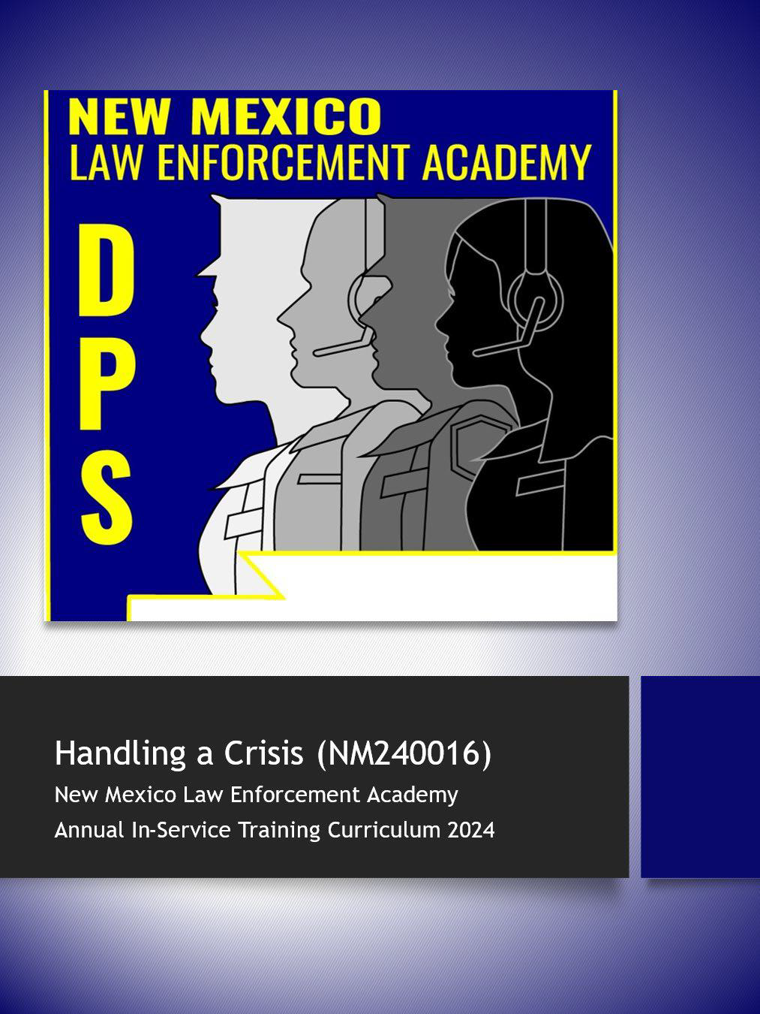
Handling a Crisis (NM260007)
New Mexico Law Enforcement Academy
Annual In-Service Training Curriculum 2026

Lesson Plan / Instructor Guide
COURSE TITLE: Handling a Crisis, management and intervention, someone in a mental health crisis, and de-escalation methods.

TERMINAL GOAL: The student will learn basic principles in crisis management and intervention, dealing with individuals experiencing mental health issues, and de-escalation methods.

ENABLING OBJECTIVES:
Upon completion of this course, the participants will:
- Identify what a crisis is.
- Identify how to manage a crisis.
- Identify how to intervene when someone is in crisis.
- Identify what mental illness is.
- Identify different types of mental illness.
- Identify behaviors that might be exhibited by someone dealing with a mental illness.
- Identify what laws pertain to assist those in need.
- Identify methods for dealing with someone who is mentally challenged.
- Identify clues and cues for someone who is contemplating suicide.
- Identify some of the considerations when de-escalating a situation.
- Identify how to approach when attempting to de-escalate.

INSTRUCTIONAL METHODS:
Classroom lecture, handouts, and visual aids (PowerPoint presentation)

HANDOUTS:
N/A

COURSE DURATION:
4 Hours

CURRICULUM REFERENCES:
- psychcentral.com/health/what-is-a-mental-health-crisis
- A Different Kind of Force—Policing Mental Illness | NBC Left Field - YouTube

with Mental Illnesses in Ontario: A Practical Guide for the Frontline Officer (Sudbury, CA:
Ron Hoffman and Laurel Putnam, Not Just Another Call: Police Response to People

Centre for Addiction and Mental Health, 2004); 10.
- Richards, K. J. (2007). De-escalation techniques. In M. T. Compton and R. J. Kotwicki (Eds.), Responding to individuals with mental illnesses (pp. 160–174). Sudbury, MA: Jones and Bartlett Publishers, Inc
- https://en.wikipedia.org/wiki/Peelian_principles
- Gary W. Noesner and Mike Webster, “Crisis Intervention: Using Active Listening Skills in Negotiations,” FBI Law Enforcement Bulletin, August 1997, 13-18, available
at http://www.au.af.mil/au/awc/awcgate/fbi/crisis_interven2.htm.
- Mental Health By the Numbers | NAMI: National Alliance on Mental Illness

EQUIPMENT, PERSONNEL, AND SUPPLIES NEEDED:
COMPUTER, AUDIO, AND VISUAL AIDS; WHITEBOARD

TARGET AUDIENCE:
NEW MEXICO LAW ENFORCEMENT OFFICERS – CADETS / RECRUITS

INSTRUCTOR RATIO:
1 / 50

EVALUATION STRATEGY: Students will participate in a reality-based scenario with instructor evaluation.
AUTHOR & ORIGINATION DATE:
SOUTHWEST TRAINING CONSULTANTS LLC JUNE 2023

REVISION / REVIEW DATE(S):
FEBRUARY 2026

REVISED / REVIEWED BY:

Reality-Based Situational Training
Reality Based Training is “any manner of training that utilizes tools, techniques or methodologies to approximate in a training setting any situation that might occur in an operational setting.” Because of the often-immersive nature of the training, the brain and body absorb and process the experience as if it were actually occurring.
The overall goal is to induce some stress based on the situation being as real or authentic as possible. This will require a few things. We will also want to make this event as safe as possible, so there are some things you should do before the training starts.
Before:
1) NO Weapons - Ensure no weapons are used in the scenarios and officers involved and watching download their weapons to a safe location. (Put your guns and tasers in another location, like locked in the car.)
2) Location - Find a secure and safe location to conduct the scenario. In the classroom is all right, but if you have the ability to use a location that is less familiar, you can bring a little authenticity to the event.
3) Role-Players – Finding role players can be a challenge. In most cases, we use the students. If you can find someone other than an officer to be your role player. A dispatcher, civilian staff, a friend, or just someone who may not have the same preconceived ideas of how this might go. You want this to be as real as possible, so finding an outside resource can be valuable. You also want to prepare them to the best of your ability. Give specific directions that are easy to follow. I want you to show sadness and despair as you have recently separated from your spouse of twenty years.
4) Scenarios – Developing a scenario can sometimes pose a challenge. Thinking about trying to keep this as real as possible, think back to the calls you have been on. You don’t want to overdo it by having the scenario be complicated, but you also don’t want the officer to not get the most out of it. When putting together a scenario, try to consider that you are looking for specific parameters to be met. Good engagement, good communication skills, and good direction toward resolution.
You will want to put together a few scenarios together before the training. Write down some ideas and walk yourself through them so you are prepared to have the role players act them out.
Make sure you manage the event by constantly monitoring how the role player is doing as well as the students. You may even want to have an additional instructor to complete the student evaluation.
5) Evaluation – Be encouraging and give positive direction on the things you see that they could have done better. Also, give positive feedback for the attributes you observed that followed the training provided. You will want the student leaving the class believing they have the skills necessary to be successful so they enter the next crisis with confidence.

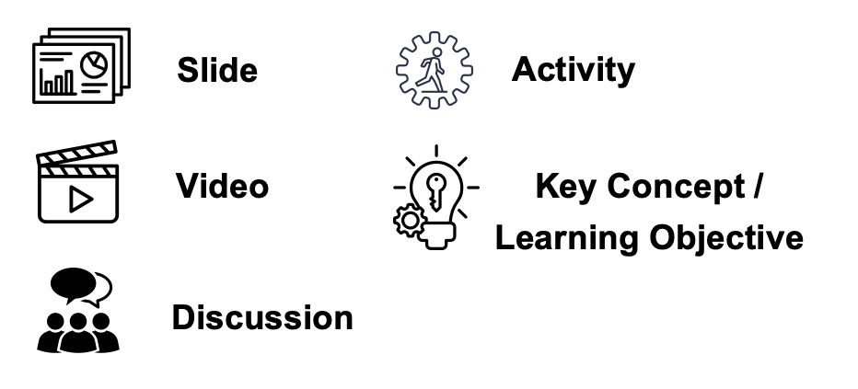
Instructor NOTES are inserted throughout the manuscript. They are used to choreograph delivery and ensure content is presented as intended by the NMLEA. The following icons are visual prompts to help instructors with delivery efforts.
The introduction is critical. It will be invaluable to immediately grab the student’s attention and let them know why this course is so important. Some ideas for starting the class:
- Ask the students what they want from the class.
- Tell them a story about a time you handled a crisis and felt there was a positive outcome.
- Show a video of an officer handling a crisis successfully. Options:
  - State Police officer saves teen from edge of Albuquerque overpass - YouTube
  - (465) Dramatic video shows Pueblo officer saving suicidal veteran - YouTube
  - (465) California deputy suffers fentanyl overdose after exposure to substance on patrol - YouTube
- Always start the class with a positive message. This will be a great class! You are going to get something positive from this training. This training will be of benefit to you in the future.

  - What you should expect from this training.
    - Handling a crisis, management, and intervention.
      - Law Enforcement across the state deal with crisis in many forms regularly. According to the American Psychological Association (APA), the most common sign of crisis is “a clear and abrupt change in behavior.” So when your behaviors and moods are not typical for you, that might mean you’re approaching or are in crisis.(1) A crisis can be a car crash, misplacing something of value, or having a loved one involved in a major event/catastrophe. It can also be an event you cannot control due to the circumstances. In some cases, those circumstances revolve around a person’s mental health. Law Enforcement is called to these types of events regularly, and the expectation is resolution.
      - During this instruction we will go over the management of a crisis. We will discuss the differences between someone experiencing a crisis versus someone dealing with a mental health crisis. We will also address things you should know when responding to a crisis.
      - Intervention, what does it mean, and how do we go about it? As we go through this training, we will discuss this again with both a crisis and a mental health crisis.
    - Dealing with individuals experiencing mental health issues.
      - A working knowledge of psychology is rapidly becoming necessary for law enforcement personnel. Although clinical assessments by the officer of individuals with whom the officer has contact are neither possible nor significant, every officer must have the knowledge to identify, evaluate, and control efficiently and safely a person requiring special consideration.
      - The law enforcement officer must practice psychology on the street rather than in a clinic, office, or university setting. In a minimum amount of time, the officer must make decisions that would baffle the academic behaviorist, decisions whose ultimate resolutions may involve months or even years of debate and legal considerations. More importantly, errors in the psychologist's decisions are seldom critical; errors in the law enforcement officer's judgment can be life-threatening.
      - As we go through this training, we will touch on the different types of mental health issues you may encounter and how you might be able to serve those persons best. We will also identify some cues to look for when attempting to identify someone experiencing a mental health concern.
    - De-escalation methods
- In most calls for service, an officer will respond when there is a need to de-escalate. Unfortunately, a lot goes into this, requiring conscious thought and preparation. We prepare for a lot of things, like what will you do if you are in the convenience store and it gets robbed. Or, when you respond to a domestic, how will you approach or where will you park? We don’t often think about how we will react to certain situations when it comes to an emotional response. What level of emotional intelligence do you have? What will your frame of mind be?
- Can you control your emotions and not elevate to the same level? Will you remain calm?
- Where will your adrenaline level be, and can you overcome that feeling to handle the situation?
ii. During this instruction, we will review what an officer can do to de-escalate a crisis. We will go over some of the things that assist in calming a person down. Some of the things we can do to help them calm down.
    - Knowing what to do in difficult instances will remove much of the insecurity which prompts rash, inappropriate, and often costly action. This is largely a result of fear, a lack of knowledge, or a general misconception. These citizens are entitled to full protection, rights, and legal privileges. Consequently, the need for informed law enforcement officers is self-evident, both for the security of these individuals and for the protection from liability of the officer. Professionalism includes a combination of both experience and education. The officer who actively encodes training and can apply it on the job increases the chances of a safe encounter with a person displaying abnormal behavior.

The way this curriculum was developed was to separate the three disciplines. However, they intertwine with each other in many ways, and you will want to focus on each one. As you progress through the training, there will be things that may be repetitive as they are significant and are focused on purposely.
Starting the block on handling a crisis, you might want to ask what the students feel a crisis is. Get them to give you examples of something they may have gone through and how it made them feel. Focus on the helplessness of the situation and identify this is how others may feel.
  - Handling a crisis, management, and intervention.
    - So, what is a crisis?
      - Crisis is defined as a time of intense difficulty, trouble, or danger. Or a time when a difficult or important decision must be made. So, depending on how they physically and emotionally respond, someone may see any situation as a crisis.
      - A crisis can be anything to anyone, as everyone is unique in what creates a crisis for them. Some of the following are crises you may have to respond to and handle:
        - Car crash
          - For many people, this is a very traumatic event, and someone involved may respond by being in shock or having little to no effect on them at all.
        - Domestic dispute
          - Imagine being in a situation where the one you love has physically taken out their frustrations on you.
        - Someone in a mental health crisis
          - Imagine being in a position where you have little to no control over your thoughts, feelings, and fears. Not everyone experiencing a mental health issue has these things, but often times people having a mental health crisis have thoughts and feelings that are overwhelming to them.
        - A missing person
          - It’s those first few moments when you realize the person is not where they are supposed to be. This can be overwhelming and traumatic for most.
        - These are just a few, but when you put yourself in any of these situations, you can see how it would or could be a crisis for someone.
Show a video on Crisis management. Discuss how the crisis started and how it worsened for him. What did he do to solve the crisis?
Crisis Management - YouTube
      - Crisis management is preparing for and responding to a sudden and significant event or situation. In most cases, these events are negative in nature and/or require intervention by law enforcement to remedy said event.
        - These events require rapid decision-making, clear communication, and effective coordination.
          - Rapid decision-making – When analyzing a situation, you often have time to process the best route to take. When a crisis occurs, you must rely on your training and experience to assist you in your decisions. The time spent at the academy, the time spent with a field training officer, and what you have experienced since all lead to enhancing your decision-making skills. You must develop the ability to handle a situation based on your knowledge of the law and understanding of what is happening quickly as an event unfolds.
Start a conversation about decision-making and how officers prepare to make difficult decisions. It is also important to discuss the consequences of those actions.
(465) Deputy fired after deadly shooting - YouTube

          - Clear communication – Good/clear communication is the key to success in most events. Being a good communicator means you can send a message that is easy to understand and clear. You also have the ability to take in information that is being passed on to you. Being a good listener is a major part of this process. Active listening skills are essential when dealing with a crisis. The skill of being a good listener must be worked on and practiced regularly to become proficient at it. When you have good communication, you have a strong likelihood of success.
          - Effective coordination – Most of the time this is based on your training and experience. Putting effort into being prepared will often result in a positive outcome. This is not much different from knowing and implementing something like the seven critical tasks. You know what needs to be done. Now it’s just a matter of effectively implementing each task. When the task is not completed, it often results in another catastrophe. This is why being prepared and effective in your coordination will assist you in handling any crisis.
            - A good way to prepare is to start processing now what you would do IF. What if, is a great way to start thinking about how you would deal with a situation and what coordination would need to take place to effectively resolve the crisis.
What if a tanker truck crashes today? What if I get a call of an active shooter at the mall? What if I am responding to a home invasion, and the suspect runs out of the house when I arrive?
Give the students a what-if. What would you do if:
- You were getting gas, and the station across the street got robbed.
- You were responding to a burglary call, and the suspect was still inside the home.
- You are called to a man with a gun and upon arrival he starts running at you.

Think about different scenarios that would cause the student to process how they might handle the situation. Specifically, get them to talk about decision-making, communication, and coordination.
You might also separate the class into small groups and give them a what-if, then ask them to break down what they would do for decision-making, communication, and coordination. Give them a scenario that would require a little more thought than an active shooter scenario.
        - Crisis management is what your job is most of the day. From a domestic to a car crash to someone threatening to jump from a bridge, you often respond to a crisis. The more you prepare the better you become at handling these events. As you go through your career, learn from those things and constantly work on improving yourself and your knowledge base. When crisis comes next time, you will be ready.
      - Intervention or to intervene – to come between so as to prevent or alter a result or course of events. You are taught the skill of intervention throughout your academy training and beyond. Frequently you are tasked with inserting yourself between two people to mitigate whatever problem they are having difficulty with. You are taught how to approach, how to communicate, how to de-escalate, and how to find some resolution. Nothing in this training should ever take away from your first priority with any event, vigilance, and safety.
      - Even though this portion of the training will be a refresher, it is still crucial.
        - Getting a call for service. (Neighbor dispute)
          - Once you receive the call, you will start trying to gather information from dispatch. Any weapons, how many people are involved, and what are the circumstances?
            - You will need to start thinking about previous events and what happened. Also, go back to your training. What should you do in this situation? You can also go through the what-ifs.
          - Upon your arrival, you will want to conduct an assessment. Where are the parties involved? Are they civil or yelling at each other? Are there any weapons present? Can you separate the parties? What else is going on around you? Where is your backup? Are there children around? Are there any other outside threats, neighbors, or people that pose an issue?
          - When you first make contact think about how you will approach. The way you communicate with people can set the tone for how this event will transpire. Think about how you would want to be approached even if you are upset, elevated, frustrated, or angry. In most cases, not all, if you approach calmly and remain calm throughout the event, you have the ability of providing a guide for how you want to be treated. Some things you may want to try:
            - Lower your tone.
            - Speak slower.
            - Be sincere in the delivery of your message.
            - Think about active listening skills.
            - If you remain calm, the agitated person(s) will oftentimes copy that behavior.
          - This may only sometimes work, and there will be times you will have to be aggressive, but make a thorough assessment and then decide on how to proceed.
          - Don’t forget you often have a strike against you going into the event. You are a police officer. You wear a badge and gun. You represent authority and can take someone to jail. This is often seen as a threat, and people respond differently.
        - You can do some things to prepare now.
          - Know the constitutional amendments.
          - Know state statutes and what applies.
          - Know your department’s policies and procedures.
          - Remember you are the peacekeeper, the person there to assist. Your role is not judge nor jury, and discipline is not a part of your responsibility.
          - Stay safe and keep those around you safe.
      - Again, this is a refresher for most, and if taught in an academy setting this training will be gone over multiple times in other disciplines.
Discuss with the students the things they can do now to prepare for future events. The scope of this portion of training is to really get the student to think about the situations they may not have come across and how they might handle them. Express to them why it is important to be educated on the law and the constitution.

This portion of the training will be a refresher for most law enforcement officers. The intent is to stay current on what is happening and how agencies deal with the changes. Many agencies nationwide have moved to a platform where they have included counselors or medical personnel in their response. Included in this is a link to a video done by NBC Left Field. The video is a documentary on Policing Mental Illness. Watch the video until 12:30 and let the students know where they can find the video online so they can watch the rest if they choose.
(465) A Different Kind of Force—Policing Mental Illness | NBC Left Field - YouTube
When you have time, please watch this so you can educate your students on what is currently happening in other areas.
  - Dealing with individuals experiencing mental health issues
    - This portion of the instruction should be familiar as it has been taught for several years now. As we go through this, we will identify some of the more current stats and try and address any new material. Please keep an open mind as this is still a very important topic to cover.
    - What is abnormal behavior?
      - Psychologists know that anyone can "come apart" under intensive and sustained stress, that all people have problems, periods of depression, and act strange at times.
      - Some who are different are labeled psychologically abnormal, while others are called creative.
      - What distinguishes the normal from the abnormal?
        - Conflict:
          - Interpersonal - two or more people.
          - Intrapersonal - within self, a conflict they can't deal with.
          - Need to decide whether interpersonal or intrapersonal conflicts are involved.
        - Other ways to respond to interpersonal.
        - But intrapersonal may be abnormal if acute.
        - The abnormal have difficulties getting out of their dilemmas by themselves.
        - The abnormal cannot make constructive use of stressful situations.
The social definition of abnormal emphasizes that abnormality is relative to one's culture.*

    - People still have a terrible time accepting mental illness without attaching an aura of strangeness. Since law enforcement officers are part of society, they, too, must learn to overcome their apprehension of those who display bizarre behavior in order to make an objective decision about whether a physician should examine the individual. Officers also need to be aware of their own intrapersonal conflicts.
Typically, people fear mentally ill persons because they are thought to be unpredictable.

    - While it may be useful to know the major categories of mental illness, the officer mainly needs to know how to react. Actions may take the form of talking, referral, commitment, or arrest.
      - To commit or not depends on whether legal requirements are met:
        - Mentally ill and either dangerous to self or others or in need of treatment in order to prevent further disability or deterioration that would predictably result in dangerousness.
        - Whether the individual is in touch with reality is an important factor to consider.
        - Definition of “dangerous” – if released, the defendant presents a serious threat of inflicting great bodily harm on another or of violating NMSA 1978 30-9-11 or 13 NMSA 1978 31-9-1.2 (D)
    - General Characteristics of Psychosis - Out of Touch with Reality
      - Major characteristics
        - Drastic changes in behavior
          - Deterioration of personality
          - Must ask relatives, friends, and neighbors for information to determine normal mode of behavior.
      - Loss of memory
        - Could be an organic, medical problem.
        - Need a medical evaluation.
        - Other symptoms include disorientation and decreased attention span.
      - Paranoia
        - Psychologists and behaviorists warn that anyone can develop paranoia--given the right combination of peer pressure and repeated exposure to one viewpoint (example: militia and extremist groups).
        - Suspiciousness, watchfulness, they believe everything has to do with them, guardedness.
        - “They're out to get me.” "They're planning to kill me."
        - Whether these individuals are faced with real dangers or not, they maintain a constant state of preparedness. They appear ever-vigilant against a possible attack and derogation.
        - Erroneous meaning is suddenly attached to innocent comments. As time passes, delusions of persecution escalate until the individual feels that he or she is under close surveillance everywhere.
        - Paranoid individuals detest being dependent because it's a sign of weakness and inferiority. Also, these individuals are unable to trust anyone.
        - Danger cannot always be predicted when dealing with people showing such a high degree of questionable suspiciousness. Paranoid individuals may become aggressive and attempt injury to anyone trying to assist them.
    - Behavior cues of impending violence
      - Facial expression - staring or no eye contact, clenched jaw, flaring nostrils, turning red
      - Verbal expression - cursing, talking loudly, threatening, complaining, talking excessively
      - Body language - increased muscle tension, clinched fists, excessive or abrupt movements, pacing, folded arms, head held down
      - Appearance - unkempt, clothes representative of aggression, e.g., fatigues
      - The officer may feel that the subject is dangerous if the subject displays any of the above listed hostile behavior cues.
    - Grandiose ideas
    - Believe they are exalted religious leaders or esteemed people from the past.
- Their antics, which may be amusing or pathetic, need not be affirmed or denied, but rather the individual should be asked for more information.
- Mania (rapidly changing ideas, constant talking, exaggerated gaiety, and physical over activity) usually accompanies grandiose ideas.
- Delusions/Hallucinations
  - Delusions - false beliefs held in spite of invalidating evidence.
  - Hallucinations - false sensations. (Example: Command Hallucinations - voices heard by Psychotics ordering them to commit acts. Studies show that people are more likely to obey these commands if they can identify the voice, such as God.)
  - Usually related to schizophrenia.
  - Accompanied by flat-sounding voice, no appearance of emotion, and loose association (sentences do not appear to make sense, no connection).
    - Visions, strange odors, and peculiar tastes
      - May be indication of physical or medical cause of mental illness.
      - May need medical evaluation.
      - May be accompanied by hearing voices.
    - Exaggerated or bizarre physical ailments
      - Complaints may seem plausible in the early stages of psychosis.
      - Safest procedure is to recommend t h e person be checked out by competent medical personnel, even though complaints sound implausible.
      - Remain alert to the fact that a person may consider the ailment so excruciatingly painful or hopelessly incurable that suicide is the only way left to end the suffering.
      - Often accompanies depression.
      - Other indicators are slow body movement, soft and flat voice, poor eye contact, and lack of concentration.
    - In all cases it is important to not discredit what the person is seeing or experiencing.
      - Do not tell the person that you see or hear what they are experiencing.
      - If what they see or hear changes and you do not know. You will lose all credibility.
      - Instead, acknowledge that you understand that they are hearing or seeing something and it is very real to them.
    - Extreme fright or anxiety
      - The person is easily startled, shows decreased ability to focus on a single subject, but may be hyper-alert.
      - Accompanying responses are easily startled, decreased concentration, and hyper-alert.
      - Fear is a major emotion for many people with mental illnesses.
      - May be so scared that they speak haltingly, jump at sudden sound, or freeze in absolute terror.
      - The sight of a uniformed officer may have a calming effect, or is likely to cause even greater fear, thus confirming the person's delusions of persecution.
    - General Characteristics of Phobia
      - Definition: Persistent irrational fear of a specific object, activity or situation which leads the individual to avoid it, if at all possible.
        - Profile
          - Panic attacks
          - Trembling
          - Uncontrollable anxiety
          - May use force to escape the problem
        - Subtypes of phobia significant to law enforcement
          - Agoraphobia - fear of being alone in public places from which escape might be difficult or help not available in case of sudden incapacitation, i.e., crowds, tunnels, or public transportation.
          - Simple phobia, such as claustrophobia - fear of enclosed places which may be seen by an officer during handcuffing, enclosure in a law enforcement vehicle with a shield, or enclosure in a holding cell.
    - General Characteristics of Antisocial Behavior
      - Definition
        - Characterized by inflexible and maladaptive personality traits.
        - Significant impairment in social and occupational functioning.
      - Profile
        - Absence of guilt and tension.
        - Impulsive and irresponsible nature.
        - History of many jobs in different locations.
        - Long criminal history (inability to profit from experience).
        - Aggression is common.
        - No morals.
        - Con-artist – adept at manipulating others and is charming.
        - Interested only in himself/herself.
        - Pleasure of the moment important.
        - Deceptive, dangerous nature.
        - Lies about everything.
        - Likes what he/she does and wants others to leave alone.
        - May kill for the simple experience of killing and seeing what it was like.
        - May threaten suicide but seldom is carried out.

n. Another group of persons with disabilities which is being served more frequently in the community is persons with autism. Autism is a severe disorder of communication and behavior. It is a lifelong developmental disability which seriously impairs the way the brain processes information sent from the senses. Characteristics include:
1. Withdrawal from contact with others
2. Very inadequate social relationships
3. Language disturbances
4. Monotonous repetitive body movement
5. Behavior problems in terms of resistance to change and emotional responses

BE ALERT FOR SIGNS THAT YOU ARE BEING TRICKED, CONNED, OR MANIPULATED!
NOTE: If your department has CAD (Computer Aided Dispatch), explain how this system can benefit your officers with information from prior incidents.
Common Warning Signs Video

    - Assessment of the Mentally Ill Individual Prior to Contact.
      - Prior experience with police
        - Type of problem
        - Prior violence
        - What worked
    - Prior to contact with the mentally ill person, communicate with complainant.
      - Family member
      - Neighbor
      - Complainant
    - Assessment at contact
      - Appearance - visual frisk
        - Strange clothing
        - Dirty, disheveled
        - Weapons
        - Eyes and face
      - Behavior
      - Speech
        - Illogical
        - Very rapid
        - Slurred
        - Very loud or very quiet
        - Irritated, angry, belligerent
      - Body language
        - Threatening
        - Open
        - Guarded
        - Defensive
      - Surroundings
        - Possible places where weapons might be
        - Packages - weapons, junk
        - Companions
        - Other rooms
      - Possibility of having taken intoxicants
        - Included in erratic behavior
        - Likely used as an attempt to self-medicate
  - Methods and Techniques of Dealing with the Mentally Ill Person
    - Ask questions of family, neighbors, or complainant.
      - Is the individual on medication? When was the last time the individual took his/her medication? Possibility on other drugs? (i.e., "Where is your medication? Can I see it?") The officer should encourage the family to contact the individual’s doctor about the prescription and/or doctor’s orders, as well as potential side effects.
      - Is he or she often violent? Any weapons?
      - What sets her or him off?
      - Will he/she go with the family or significant other to the area facility? (The officer should suggest possibilities of voluntary commitment or a family member initiating papers if requisite criteria are met.)
    - Take time to assess the individual and environment unless the person is endangering self or others.
      - Give the person time to quiet down.
      - Try to find out what is going on. Be a good listener.
      - Do not give the impression that there is not time for them.
    - Do whatever is possible to provide a non-threatening environment.
      - Keep a safe distance.
        - Individual is probably frightened or angry. If he or she is hearing voices and those voices are saying that the officer has come to punish or hurt, the person may turn against the officer without apparent provocation.
        - People have areas of space around them that should be respected.
        - Intimate under 18"
        - Personal - 18" to 36"
        - Social - 3' to 6'
        - Public - over 6'
    - Officer should remain in social space; however, space is situational. The more threatened the individual feels the more space needed.
    - Your actions should be slow, and prior warning should be given if you intend on moving about the room.

      - Interpersonal communication skills
        - Use normal yet firm voice, convey image of quiet self-assurance.
        - Effective listening
          - Reinforce communication by repeating back what the person is saying, using different words-paraphrasing. (i.e., "I understand that you are feeling .")
          - Summarize what the individual said, making sure the facts are straight.
          - Use a non-judgmental manner.
    - Avoid trigger words such as lunatic, nut, or crazy.
      - Encourage the person to talk.
      - Do not threaten or abuse.
      - Explain in a firm, but gentle, voice that you want to help. Ask how you can be of assistance. Develop a sense of working together: “Help me to understand what is happening to you.” If they are fearful of your equipment, take the time to explain that you carry the equipment to enable you to perform your job, which is to protect the public and them.
      - Avoid behavior that might appear threatening.
        - Fidgeting with tools on your belt.
        - Avoid standing over a sitting individual.
        - Honor personal body space—keep distance.
        - Be aware of your facial expressions.
        - If there are numerous officers, avoid surrounding the individual.
      - Minimize unnecessary sensory input, such as noises and crowds. These tend to confuse the subject.
      - Call back-up if at all possible. Do not act alone.
      - Do not take anger personally. They are not necessarily mad at you.
      - Give choices whenever possible to allow some level of control.
      - Try not to lie to or deceive the individual. Try negotiating instead, i.e., "You might have to go to the hospital, but there are other alternatives."
      - Be alert.
        - They may exhibit a burst of extreme strength and may appear impervious to pain, especially if intoxicated by drugs.
        - The individual is unpredictable and may not respond in the manner expected by the officer.
        - Do not be fooled by a sudden return to reality; the person can just as quickly return to crisis.
      - If physical force becomes necessary for apprehension:
        - Restraint should preferably not be attempted by one officer alone. Mentally Ill persons often have short bursts of extreme strength.
        - The person should be maneuvered into an area where he/she is least likely to be hurt upon being restrained.
        - Know where your firearm is at all times.
        - THINK SAFETY AND TREATMENT--YOU ARE NOT ARRESTING.
        - Conduct a thorough search of the person for officer and patient safety but do so with extreme caution (possibility of needles or blades).
        - The officer should always be aware that if his or her life or t h e l i f e of another is imminently threatened, necessary deadly force can be used.
Interacting with Persons with Mental Illnesses (3) Do:

- Collect as much information as possible from all possible sources prior to intervening. Take your time and eliminate noise and distractions.
- Ask permission first.
- Treat them with dignity and respect as you would a family member. Keep your distance and respect personal space.
- Talk slowly and quietly. Identify yourself and others and explain your intentions/actions.

If involuntary commitment becomes necessary, the following commitment procedures should be followed:
        - Type of commitments
          - Voluntary commitment – an individual voluntarily enters a treatment facility.
          - Emergency/ Involuntary commitment – a peace officer may detain and transport a person for emergency mental health evaluation and care without an order if:
            - The person is otherwise subject to lawful arrest or
            - The peace officer has reasonable grounds to believe the person has just attempted suicide or
            - The person presents a serious danger to self or others and immediate detention is necessary or
            - A licensed physician or certified psychologist has certified that there is a likelihood of serious harm to self or others.
              - Note: A detention facility may be used only for temporary shelter and in no event for longer than 24 hours. The person shall be protected and treated with dignity and protected from others and from possible suicide attempts. NMSA 1978 43-1-10
            - A person shall be informed orally and in writing by the evaluating facility of the purpose and consequences of any proceedings and allegations, the right to a hearing, the right to counsel and to consult with a mental health professional.
NMSA 1978 43-1-10
            - A person may be involuntarily committed only after a hearing within 7 days of admission. An involuntary commitment may not exceed 30 days whether by court order or District Attorney Petition. NMSA 1978 43-1-11
            - The following is a list of indicators that a person may be a danger to self or others:
            - Suicide attempt
              - Threats of suicide
              - Self-infliction of bodily harm
              - Threats to inflict bodily harm
              - Failure to care for self
              - Infliction of harm on another
              - Threats of harm directed at another
** Documentation of an officer’s observations of the above factors is of the utmost importance in order to establish a foundation of care for the mentally ill and to protect the law enforcement officer from civil liability.
          - Assessment #1. Transport subject to appropriate facility for the first evaluation by a physician or licensed psychologist.
            - Facility
            - Transport the subject to a local emergency room for evaluation.
          - Findings of assessment #1
            - No commitment – A physician/psychologist may feel commitment is not warranted at this time. This will end the process. Return the papers and transport the subject back to his residence, or with the subject’s consent, to the house of a consenting individual located in the originating county.
          - Assessment #2. The 24-hour facility
            - A 24-hour facility is any mental health facility that provides acceptance of clients on a 24-hour basis.
              - State facilities – Las Vegas, NM (only on a commitment order)
              - Private facilities –Charter Hospitals, etc.
          - Findings of assessment #2
            - No commitment – A Physician/psychologist may not feel commitment is warranted at this time. This will end the process.
            - Examples
            - An officer responds to a suicide attempt call. The subject has cut his/her wrists but refuses medical treatment.
            - A subject is on medication for mental illness but refuses to take it.
            - The family calls law enforcement to prevent the subject from hurting him/herself.
      - Substance Abuse
Various consequences from the abuse of drugs can occur. The interaction of a combination of drugs poses severe and dangerous health problems. People with serious mental illness have their disorders exacerbated by using alcohol and drugs. If they are on medication for their illness and have mixed it with other drugs, they need to be evaluated by professionals in a treatment facility.
        - General effects such as:
          - Sedation, depressed respiration, a semi-hypnotic state, contracted pupils, depressed reflexes, and intoxication.

          - Lack of pain or fatigue.
          - Lack of coordination, restlessness, excitement, disorientation, confusion, and delirium.
          - Hallucination, pupil dilation, increased blood pressure and body temperature, depressed appetite, and on occasion, nausea and chills.
        - Withdrawal effects such as:
          - Sweaty, fearful, and tremulous.
          - Restless, agitated, and convulsions.
          - May hallucinate or have delusions.
          - Hot and cold flashes, vomiting, diarrhea.
          - Emergency medical personnel should be contacted for transporting to the emergency room.
        - Remember the assessments and techniques for handling mentally disturbed individuals, especially those who are potentially violent.
          - Substance abusers, especially those on stimulants, may be impervious to pain and may exhibit extraordinary strength.
          - While mentally disturbed individuals can often be calmed down, the substance abusers, especially those on stimulants cannot be calmed down easily. Back-up should be requested and more than two officers may be necessary to prevent injury.
          - Unpredictability is a key factor for an officer to keep in mind.
        - Arrest should be considered when there is probable cause that a criminal offense has been committed.
          - This may actually help the person to realize that he or she has a problem.
          - Try to remember that alcoholism and drug addiction are serious illnesses that require treatment.
          - Assess the individual's awareness that they are being arrested (i.e., "Do you understand that you are being placed under arrest?").
          - The abuser's reaction to officer confrontation varies depending upon:
            - Whether the abuser is under the influence of a drug or just in possession of it.
            - The type of drug taken and the effect it is having on the abuser.
          - Some jail policies state that subjects under the influence of drugs will not be admitted. These subjects must first be transported to a hospital. Be sure to check with your local department for admitting procedures.

  - Methods for Dealing With Mentally Challenged Persons
    - Definition
      - In general, a mentally challenged person is one whose learning capacity is limited. The degree of challenge varies widely, from those who must be institutionalized to those who can maintain a routine job.
      - Many of the persons who are mentally challenged have comparatively minor difficulties with learning and social functioning and are in the mild or moderate range. Remember, persons with mental challenges are not mentally ill.
    - Psychological profile elements: mentally challenged
      - May be unable to formulate thoughts and answer questions readily.
      - May have speech defects.
      - May appear interested in children as they can better understand what children are doing.
      - May have slow responses similar to alcohol or drug abuse.
      - Often they have poor judgment.
      - Often unable to foresee the consequences of an act.
      - Easily influenced by an authority figure.
      - Often inadequate in their personal relationships.
      - Socially immature.
      - Resent unkind nicknames/teasing and may do something foolish because of it.
      - Some mentally challenged persons are quite sensitive and very aware that they are different.
      - To compensate, some mentally challenged persons may become aggressive in order to feel “important."
      - Awareness of being different may be responsible for feelings of inferiority, frustration, and resentment; as a result, they are less tolerant to stress.
      - Fear may be the major characteristic in a confrontation with an officer.
      - Potential for violence or aggression exists since the appropriate outlet channels may never have been learned by the mentally challenged person.

    - Criminal profile
      - Feelings of inferiority mentioned earlier may cause aggression toward others.
      - Burglary, improper sexual behavior, theft, and vandalism are other common criminal acts committed by mentally challenged persons - usually at the instigation of others.
      - A mentally challenged person is easily influenced to be led into criminal behavior.
      - This individual is frequently the victim of criminal behavior.
    - Methods to deal with a mentally challenged person:
      - May come in as a missing person complaint - may have gotten lost and is wandering aimlessly.
      - GO SLOWLY – rapid questions during an interview or confrontation may confuse or frighten the person.
      - Patience is needed to overcome a communication barrier and alleviate any exaggerated fears.
      - Rephrase questions into simpler language if it appears the person does not comprehend.
      - Minimize unnecessary sensory input - noises, crowds, as they may confuse the person.
      - Identification and information concerning parents/guardians are important to establish immediately. Many mentally challenged persons carry cards with information of important contacts written on them.
      - If there is any doubt, ask if they go to a special school.
      - Misinterpretation of acts
        - The individual may quickly go to their pocket to get their contact card which contains their parent, doctor, or employee name and number.
        - Fear of the officer may take the form of flight.

  - Suicide

    - Myths and facts
      - "People who talk about suicide won’t commit suicide."
        - Eighty percent of successful suicides previously either threatened suicide or made a suicide gesture.
      - "Suicides happen without warning."
        - Most often the person clearly warns of his intentions. Less than 50% of suicides result from panic type behavior.
      - "Suicide and depression are synonymous."
        - Depression, though common, is only one of many symptoms that occur.
    - Signs indicating that suicide is being considered.
      - Drastic behavior changes
        - Insomnia
        - Weight loss, appetite loss, self-imposed starvation
        - Withdrawal from usual pursuits, activities
        - Decrease in sex
        - Sadness/crying
        - Mood variations
        - Lethargy
        - Excessive risk taking
        - Unreasonably high expectation for success in job or business, academics/athletics
      - Verbal cues
        - Feeling hopeless/helpless
        - Talking only about past
        - Saying "I'm going to kill myself"
      - Prior history
        - Prior attempts or family history of suicide
        - History of mental illness
      - Indirect cues
        - Makes will/ changes will
        - Gives away prized personal possessions
        - Makes funeral plans
      - Job history
        - Loss of employment
        - Business reversals
      - Medical history
        - Recent/chronic illness
        - Hypochondria
        - Refusing to follow doctor's orders or to take medication
      - Marital difficulties
        - Recent marital problems
        - Loss of family member, death, or rejection
      - Financial difficulties
      - Alcoholism
      - Psychosis
    - Statistics
In 2023
Suicide was the eleventh leading cause of death overall in the United States, claiming the lives of over 49,300 people.

Suicide was the second leading cause of death among individuals between the ages of 10 and 34 and the fourth leading cause of death among individuals between the ages of 35 and 44.

There were over two times as many suicides (49,316) in the United States as there were homicides (22,830).

i. Sex
1. Attempted suicide women outnumber men 3:1
2. Completed suicide men outnumber women 70% to 30%

ii. Ethnic variances

1. Whites have a suicide ratio of approximately twice that of African Americans.
2. Native Americans have highest rate in U.S.; Eskimos have the highest rate in the world.

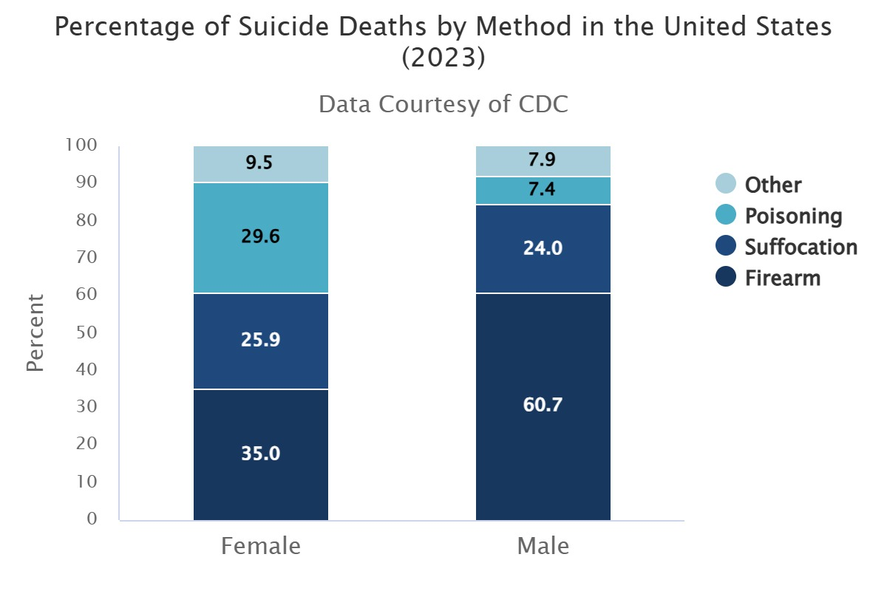

      - Methods
        - Sleeping pills and other pharmaceuticals
        - Hanging and strangulation
        - Firearms and explosives
          - Use of pistol versus shotgun more frequent
          - Usually shoot in temple, face, or heart
        - Males
          - Attempts: barbiturates
          - Commits: guns, hanging, carbon monoxide
        - Females: Attempts/Commits: barbiturates
      - “Suicide by Cop” - method used by individuals to force officers to use deadly force against them.
        - Typical scenario includes: an individual with a prior history of mental chronic physical illness, alcohol/substance abuse, incident initiated by subject or third party to ensure police response, suspect forces confrontation, aggressive action toward police, presence of deadly weapon and threatens officer(s), advancement by suspect toward officer(s) even if officer is retreating.
        - Officer options may be limited - must also protect themselves and/or third party.

      - Police suicide
        - Suicidal rates are higher among professions with high stress potential; law enforcement agencies are included in this group.
          - Different research places law enforcement suicide rate in comparison to the general population at different levels.
          - Highest rate among officers with marital problems, problems not directly related to the job.
        - Need to be alert for suicide warning signs among fellow officers; know how to get help within the department or how to refer to a special assistance program.

  - De-Escalation
    - To de-escalate – reduce the intensity of (a conflict or potentially violent situation)
    - One of the myths about policing involves the idea that police officers are primarily crime fighters. Yet, less than one-third of a patrol officer’s activities are actually devoted to law enforcement; the majority of his or her duties are focused on service activities, maintaining peace and order, and problem-solving (Walker & Katz, 2008).
Get the students to talk about things they have done to de-escalate a situation. Ask them about a time when they used some of the techniques they had previously been taught and how it worked out. See what has worked and what did not work as well.
    - The term de-escalation generally refers to the act of moving from a state of high tension to a state of reduced tension. (5) As the responding officer, your responsibility will be to reduce that tension and attempt to resolve any conflict peacefully. Because you will deal with a large variety of personalities and different scenarios, there is no golden rule on how to approach these events. However, there are several things to take into consideration when you are dealing with an event that requires you to de-escalate.
      - Your presence
        - By showing up you will cause a change in the behaviors of people.
          - Sometimes for the better, as people will not want to face a consequence for their actions. People may also feel secure in the fact that someone is there to help them.
          - Sometimes for the worse as they may have had a previous bad experience or feel a certain way about law enforcement.
      - Your ability to remain in control of your emotions, having emotional intelligence.
        - Emotional intelligence is the ability to understand, use, and manage emotions in positive ways. People with high emotional intelligence can communicate effectively, empathize with others, overcome challenges, and defuse conflict.
        - Being able to control your emotions and feelings sometimes is more difficult than we believe. We were brought up a certain way and have a set of beliefs that have guided us to this profession. You hold yourself to a standard and when someone else deviates from that standard it can be incomprehensible. You have to be able to control your emotions and feelings no matter what the circumstance. A well-versed officer may appear to “not care,” but in most cases that is furthest from the truth. They have learned how to internalize those emotions so to the general public he or she is a rock, someone you can count on. The reality is they are dealing with those things some other way. This gets into a topic we will discuss in other trainings, Stress management and officer wellness.
      - Being professional
        - Professionalism goes a long way. Being a police officer means you are the paid faction of society who is responsible for keeping the peace. Although the profession has gone through a lot over the years the community still has an expectation that you will be professional in your approach, your dealings with the situation, and even if you have to arrest someone. When you have the ability of remaining professional in handling a situation you have the ability of gaining the respect of those involved. Although that may not be the focus of how you do your job, in the long run, it will help. Peelian principal #2 states: To recognize always that the power of the police to fulfil their functions and duties is dependent on public approval of their existence, actions and behavior, and on their ability to secure and maintain public respect. (6)
        - Being a professional is not difficult and is a choice. Practice this and you will more often than not find favor in those actions.
      - Being a good communicator
        - This is one of the most critical aspects of all when dealing with someone in crisis. Being a good communicator has a lot of different components.
          - Being able to convey a message in a way that leads to confidence in the receiver.
          - Using active listening skills
            - I message: An attempt to confront the subject, encourage positive behavior, and discourage negative behavior (e.g., “I feel (emotion) when you (behavior) because (reason).”)
            - Paraphrase: Rewording or rephrasing of the subject’s statement in the negotiator’s words.
            - Emotion label: Identification and articulation of underlying feelings.
            - Summary: Periodic review of the main parts of the subject’s
story and the accompanying feelings.
            - Effective pause: Silence before or after saying something meaningful.
            - Minimal encourager: Brief responses (sounds) that indicate the negotiator is listening.
            - Reflection: Repeat of the last few words spoken by the subject
            - Open-ended question: Questions requiring more than a “yes” or “no” answer, typically beginning with “who,” “what,” “when,” “where,” and “how” (The authors discourage the use of “why” because it potentially is accusatory and confrontational.)
          - Overall, it means to be present and give the person the time they need to convey their message.
There are several videos out there that show active listening as a skill. Offering one of the following and then talking about how it is applied will help the student better understand its effectiveness.
- (465) It's Not About The Nail - YouTube
- (465) The Big Bang Theory Active Listening - english sub - YouTube
- (465) Empathy 101 Phil Dun-empa-phy - YouTube
It is also a useful tool to start a conversation. Think about something you think others may like and start a conversation. Hobbies, cooking, working out, whatever it is really dive into what it is they like about it. Use some of the active listening techniques. Then when you are done go over some of the things you did to show you were actively listening. Try and do this where they may not be aware of what you are doing until after the fact.
      - Showing empathy
        - Empathy is the ability to understand and share the feelings of another. This is a skill that requires practice but will have big dividends when you can identify an emotion or feeling of another and do so in a way that lets the person know you are worried about their plight. You have the ability to be very successful with getting them the assistance they need and getting them somewhere where they can get better. Success in this profession can be something like talking a person off the ledge when you are empathetic to their story. Understand, this is a good practice and may only sometimes resolve or assist in resolving an event.
      - Being patient
        - This is also very important as someone in crisis may need time to comprehend what is actually happening. When dealing with someone in a mental health crisis, this may take some time, and you have to show them you are willing to put in the effort. This also shows that you care, which for a lot of people, is more important than anything else.
      - Being compassionate
        - This is hard to imagine if you have never been in a crisis before or something similar to what the person is experiencing, but compassion makes a huge difference. Compassion is often regarded as being sensitive to the emotional aspects of the suffering of others. Letting the person know you regret the situation they are in or lending an ear so they may get things off their chest, is a way of being compassionate.
      - Being genuine
        - When you have a conversation with someone it is often easy to tell when someone is fake or has somewhere else they want to be. This is shown by looking at your watch or rolling your eyes, maybe even looking around like you are bored. The person who is experiencing a crisis may need you now more than you will ever know. Their life might be turned upside down and they just need someone to be there, someone who shows concern, someone who will present themselves in a way that makes the person in crisis feel secure. When you are genuine or authentic in your approach the person in crisis will hopefully be able to calm down and or rationalize with what is going on.
Focus on why each one of these things is important. Try and relate each of the above tasks to a scenario or situation that would help them visualize how it would work or help them with whatever crisis they are dealing with.

VIDEO: Teen with Gun

    - There are also some things to take into consideration when approaching someone in crisis.
      - Be aware of your surroundings.
        - People are capable of anything. Never let your guard down. Safety is paramount. Pay attention to what is going on in front of you and make sure you have the support to watch everything else.
      - Take your time.
        - Everything in this world moves way too fast. We are all late for something. This is one of those calls where taking your time could be beneficial. Even if you think you are not getting anywhere with the person, often times, it takes a little bit for them to calm down and get their wits about them.
      - Don’t make sudden movements.
        - You do not want to incite any issues by being too aggressive. In most cases if you will just talk to the person you will find getting closer becomes easier and easier. They need to feel comfortable with you before they let you close.
      - Attempt to isolate the person.
        - Having outside sources involved in the event is almost never a good thing. You have no idea what they might say or do. To eliminate the threat of something else setting them off just isolate them and talk to them in a quiet space.
      - Body language is important.
        - If you have children, you know this. Rolling your eyes because you may not believe what they are telling you sends the absolute wrong message. Look, even if you do not agree or believe in what they are saying, be respectful and watch how you present yourself. Folded arms, looking away, holding other conversations, interrupting, and looking at your phone are all things you need to avoid when trying to de-escalate a person.
      - Remain calm.
        - In most cases, your calm demeanor will model the behavior you want to see in someone else. When you are trying to get someone to calm down, remaining calm is a great start. A few other things you can do is lower your tone, speak slower, and don’t be condescending. Make it where they have to listen a little harder to know what you are telling them.
      - Don’t argue.
        - This, in almost every case, does not help. There is no real good time to argue with someone about anything. It is counterproductive and has the ability of making things worse.
    - When working to de-escalate any situation don’t forget the golden rule, treat others how you would want to be treated. Your mom said this to you a thousand times and she was right. People generally respond better when they feel valued and respected.

Safety is paramount. Please reiterate that there is nothing that should compromise their safety and the safety of others.
I would encourage you to do a little research of your own as you may find literature or videos that would suit the direction you are taking when teaching this course. Again, think about how this can be a positive experience for the student and give them the tools they need to be successful.

  - Conclusion
    - The intent of the training is to continue to challenge you as a law enforcement professional by making you stronger in the area of handling a crisis. The more you know and the more often you handle these calls, the more proficient you will become.
    - We went over what a crisis is. Identifying a crisis can be many things, and for everyone, it is different. We went over how to manage a crisis and what to do when you have to intervene. Again, this may be a refresher to most, but the intent is to sharpen your skills and continually remind you of the tools needed to be successful when handling a crisis.
    - We then went over mental illness. What it looks like, and how to identify signs and symptoms. We went over how to approach someone dealing with a mental health crisis. We also addressed the things you, as an officer, should be aware of when dealing with these calls.
    - We also went over the process of de-escalation. The things you should be aware of in your approach. How to prepare for these types of calls. Some of the do’s and don’ts.
    - When this is all said and done, it is about helping people through whatever crisis they may be experiencing. Although it may not seem like a major event to you, everyone handles things differently, and they respond differently. We want the students to be successful in all they do, especially when dealing with someone in crisis.

Evaluation
This course requires an evaluation of each student to identify whether they have reached a minimal level of competency with the material taught. As the instructor, it is incumbent on you to have some measurable device to ensure the student has a basic understanding of the lesson content. To complete an evaluation, a reality-based scenario is required. Students will be afforded an opportunity to address someone who is in crisis. As the evaluator, you will be looking for specific things related to their performance. Included in this lesson content is an evaluation form. Please read over it before use and know what benchmarks you are looking for. Also, there is a notes section for you to identify anything you would like to bring up after the assessment, good or constructive.

COURSE AUDIT
COURSE AUDIT (Continued)

37

PRIMARY INSTRUCTOR:

SECONDARY INSTRUCTOR:

SUPPORT STAFF:

DATE(S)/ TIME(S) OF INSTRUCTION:

LOCATION OF INSTRUCTION:

RECOMMENDED CURRICULUM CHANGES: Identify inaccurate information, outdated information, new information to be added to update material, etc. (Use additional pages if necessary)

ADDITIONAL INSTRUCTOR COMMENTS: (If any portion of the course content was not presented, indicate the specific content here)

Alternative curriculum was taught.

Accreditation number of alternative curriculum:
SIGNATURE DATE

Primary Instructor

Reviewed by Program Coordinator

Reviewed by

Reviewed by Director/Chief or Designee

