Lesson Plan / Instructor Guide
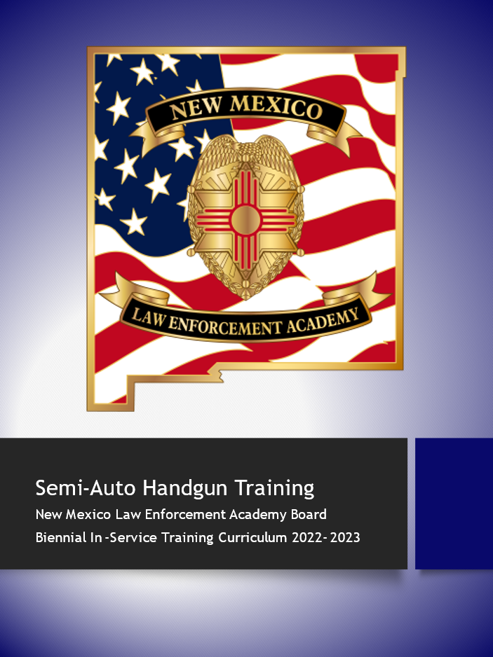

COURSE TITLE:
2022-2023 In-Service Semi-Auto Handgun Training

INSTRUCTIONAL GOAL:
This course will enhance or reinforce an officer’s ability to operate their semi-auto handgun during stationary & dynamic training evolutions in both daylight and low/no light environments, while using cover and movement to enhance their safety and effectiveness, to include decisional aspects of firearms use.
INSTRUCTIONAL OBJECTIVES:
Upon completion of this block of instruction the participant will:
- Recite the four general firearms safety rules
- List & demonstrate the 7 fundamentals of handgun marksmanship
- Demonstrate & discuss the handgun presentation
- Demonstrate their ability to shoot on the move, laterally, forward & rear and diagonally, while maintaining shot placement accuracy and accountability
- Demonstrate the ability to properly utilize cover (barricade or vehicle) and fire from cover (both from braced or on cover & with distance from cover) in standing, kneeling & prone positions from the Officer’s “strong” and “off” sides in all positions
- Demonstrate, articulate, identify and resolve the 4 primary weapons system malfunctions; failure to fire, failure to eject, failure to extract and out of battery.
- Demonstrate proficiency in performing a tactical & speed re-load, including discussing when each would be performed
- Demonstrate the ability to engage targets at varying distances and threat levels to include prioritizing their target engagement.
- Demonstrate the ability to correctly identify and engage threat and no threat targets
- Demonstrate the ability to operate and maintain operation of their weapon system with strong and support/off hand only to include; Draw from holster, reloading and malfunction clearances of failure to fire, eject & extract while maintaining shot placement accuracy & accountability.
- Demonstrate weapons retention shooting and articulate when or where this technique would be used, while maintaining shot placement accuracy & accountability
- Demonstrate the ability to perform all of these same techniques in low light conditions while utilizing a handheld & Weapons mounted flashlight.

10.29.7.8 NMAC A-6: “Four hours training of academy approved day and night firearms training on agency approved weapons systems including, but not limited to, duty handgun, backup handgun, shotgun, and rifle. No more than one-hour training shall be classroom lecture. A minimum of three hours training divided equally between day and night training, and shall consist of practical exercises using live fire, Simmunitions®, Airsoft® or other firearms training systems. Qualification testing may not be used as training to meet this requirement.”

INSTRUCTIONAL METHODS:
Lecture, demonstration & class Participation – Live fire

HANDOUTS:
None

COURSE DURATION:
4 hours
(No more than 1 hour lecture, the remaining split between day and low light)

CURRICULUM REFERENCES:
NMLEA Advanced Training Bureau Firearms Instructor Manual
EQUIPMENT, PERSONNEL, AND SUPPLIES NEEDED:
Body armor, hearing & eye protection, billed cap, and any or all other firearms live fire safety equipment necessary. Firearms range with targets and barricades
TARGET AUDIENCE:
NMLEA Certified Firearms Instructors

INSTRUCTOR RATIO:
1:30 Lecture, 1:5 day Live Fire, 1:3 Low Light Fire, 1:1 Shooting on the move or Stress Courses

EVALUATION STRATEGY:
Participation, demonstration

AUTHOR & ORIGINATION DATE:

REVISION / REVIEW DATE(S):
1/27/20
REVISED / REVIEWED BY:
NMLEA ATB Staff

COURSE OUTLINE:
- Weapons Handling and Safety Considerations
No mechanical device has a will of its own, and firearms never “go off” unless somebody causes them to do so. Firearms are safe. It is people and their actions or oversights that when combined with a loaded firearm are dangerous.
In the interest of controlling this human factor and its associated risk, the following safety guidelines should be followed.
Four General Firearms Safety Rules
- ALL GUNS ARE ALWAYS LOADED. Do not "pretend" this is true; be deadly serious about it. For practical police purposes we must maintain our weapons in a loaded condition. There is no reason to consider any weapon not to be loaded. Strict adherence to this principle will eliminate that pathetic excuse, “But I didn’t know it was loaded.”

- NEVER LET THE MUZZLE COVER ANYTHING YOU ARE NOT WILLING TO DESTROY. A simple common-sense principle that unfortunately is conspicuously and continuously violated.

- KEEP YOUR FINGER OFF THE TRIGGER UNLESS YOUR SIGHTS ARE ON TARGET AND YOU’VE MADE THE DECISION TO FIRE. You cannot line up any faster than you can position your finger, and there is no need to fire an unaligned weapon. Many accidental discharges have occurred by someone applying their finger to the trigger while the weapon is still in the holster, or during the drawing sequence. The process of pointing a gun at an intended target takes much more time than it takes to move the trigger finger from the position along the frame/trigger guard to the trigger.

- BE SURE OF YOUR TARGET. Know what it is, what is in line with it, and what is behind it. You are responsible for any round you send down range. Do not fire at anything you have not positively identified and don’t intend to shoot.

The Seven Fundamentals of Marksmanship
- The Stance
  - A constant, stable shooting platform is essential. Utilizing the “natural point of aim,” the Weaver or Isosceles Shooting Stance is incorporated.
- The Grip
  - A consistent and stable grip is mandatory to afford proper shooting.
  - The strong hand must be as high on the stocks/back strap as possible, allowing recoil to be absorbed straight back rather than the weapon rocking excessively in the hands.
  - The support hand supports the strong hand with the fingers wrapped around the strong hand fingers. The meaty part of the thumbs should be touching.
  - A light push-pull effect occurs with the support hand pulling back, and the strong hand pushing forward. You must have “power in the hands” to control recoil.
  - The strong-arm should be as straight as possible and the support arm should be bent down and in. A goose neck is formed in the support hand.
- Sight Alignment
  - Relationship of the front sight to the rear sight.
  - When looking through the rear sight, the front and rear sights are aligned so that the tops of the two sights are flush and there is an equal amount of daylight (space) on either side of the front sight.
- Sight Picture
  - Placing the sights on the target is called sight picture. Correct placement of the sights is between the shoulders of the adversary. This is known as a “High center mass” hold. Police weapons should be zeroed so the bullets strike the target directly under the area covered by the front sight. This is known as a “Combat zero.”
  - The human eye can only focus in one focal plane at any given time. Since the rear sight, front sight, and target are at all different distances the eye is not able to focus on them all perfectly at once.
  - All focus and concentration must be on the front sight to maintain good accuracy.
  - As the weapon is brought on target, the focus moves from the target to the front sight as the decision to fire is made. This is known as “Flash Sight Picture.”
- Breath Control
  - Proper breathing allows the shooter to fire more accurately. This is critical as the range to the target increases, or the precision of the shot becomes more important (head shot, hostage situation).
  - If possible, the shooter should attempt to fire during the “respiratory pause,” between breaths.
  - Under street conditions, though, this may be difficult. The shooter should try to at least hold his breath while actually pressing the trigger.
- Trigger Control
  - Trigger control is the most critical fundamental of marksmanship. The best sight alignment and picture will be wasted if the shooter slaps the trigger.
  - The trigger must be pressed straight to the rear, without allowing the sights to be misaligned. The actual firing of the weapon should be a surprise.
  - This “surprise break” occurs whenever increasing pressure is applied to the trigger. The time frame is short, a fraction of a second, but the firing of the weapon is still a “surprise.”
  - The finger should be placed on the trigger to allow a straight press to the rear. For revolvers and D/A autos that is actually the first joint. For S/A autos the first pad.
- Follow Through
  - After the weapon fires, the front sight is held or placed back directly over the original point of aim. This helps alleviate the muzzle moving during dwell time (the time after detonation but before the bullet leaves the barrel) as well as prepares the shooter for a second shot.
  - For one shot, the shooter should have two sight pictures. For three shots, the shooter should have four sight pictures.

Performance Objective #3
Weapon Presentation
1. The Grip
Without moving the rest of the body, the strong hand acquires a shooting (firm final firing) grip on the weapon, with the web of the hand riding high on the stocks/back strap. The strong elbow should be behind the shooter, rather than out to the side. As the strong hand is getting the proper grip, the retention device (s) are released. Simultaneously, the support hand moves to the body’s high mid-line.
2. Rock and Lock
As the weapon is drawn from the holster, the muzzle is rotated forward as soon as it clears the holster; the strong wrist is locked against the body, directly below the pectoral muscle (nipple line). Single action semi-automatics should disengage their safeties at this point, allowing the shooter to fire from the weapon retention position if necessary.
3. The Grab
The gun hand punches the weapon straight toward the target. As the weapon moves forward, the support hand meets the gun hand for a stable two-handed grip. Elbows should remain close to the body. In the modified weaver position the support hand is pulling against the outward pressure of the strong hand at this point. When using the isosceles position both arms will build power at the same time. This helps the muzzle stop immediately when brought up to sights.
SHOOT OR CHALLENGE?
At this point the officer may have to fire the weapon or may be drawing the weapon to challenge a suspect, or simply have it out of the holster in fear of an imminent deadly threat.
Assuming the officer will fire the weapon, the count will continue. Should the officer be drawing to challenge or prepare for an imminent threat, most of the time the officer will draw to the low ready.
Instructors should include “Shoot/Challenge Drills” in their training of their officers. Conditioning an officer to draw and fire all the time is not realistic to what occurs on the street.
4. Lock-Out
The gun continues towards the target and finally comes “in line” between the shooters eye and the target. The weapon is brought up to eye level; do not tilt the head down. The weapon remains in a strong two-handed grip, with a push-pull effect in modified Weaver position or a push-push in the isosceles position. The support hand pulls straight back while the strong-arm pushes forward. The strong-arm is extended as straight as possible. In the modified Weaver position, the elbow of the support arm is bent and pointed downward rather than to the side, while in the isosceles position, both arms will be locked, and shoulders rolled slightly forward.
On a square range, during the four drawing steps, the torso of the body should not move. The only parts that need to move are the arms. In the real world, the officer should be seeking cover if not already there, and then muzzle and trigger finger consciousness are critical to preventing a negligent discharge of the weapon.
Shooting on the Move
At times it may be necessary to shoot on the move, such as being attacked while moving to, or between positions of cover. This can be accomplished if the shooter maintains a stable upper body or shooting platform.
The officer is in the modified Weaver or isosceles position or low ready. The officer bends his knees and walks with the weapon on target or low ready. When the decision is made to fire, the weapon is brought up to eye level and the arms lock out in the traditional manner. When shooting on the lateral, behind the strong side, it is sometimes easier to utilize a one-handed shooting technique. If these techniques are new to the shooter, or they have not performed them in a long time, a dry fire run is recommended before going to live fire. It is recommended that these drills be performed with one shooter online at a time and a dedicated Instructor to move with the student Officer.
It is preferable to move diagonally when moving forward or to the rear, rather than straight forward or straight to the rear.

Barricades

The use of cover and concealment is critical in a lethal confrontation, and the effective use of some sort of barricade (cover) can greatly increase the officer’s chances of survival. Minimizing the size of the target presented by the officer is one reason to always seek cover and at least concealment. The difference between cover and concealment is simply: cover stops or otherwise impedes direct or indirect fire; concealment partially or wholly prevents the officer from being seen. Barricades may also be used to provide additional support for the shooter. When using a barricade for additional support, the shooter must ensure that the barricade will not move when firing because it may alter the bullet’s point of impact.

NOTE: The hands may rest against the barricade, but care should be taken on rough surfaces. The weapon should not touch the barricade, it may cause a malfunction on semi-autos, additionally, and the weapon should be canted when shooting around left barricades to prevent the possibility of spent shells bouncing back in the action.

Standing

- The presentation remains the same, using the barricade for concealment/cover.
- Press the knuckles or the back of the hand against the barricade.
  - Be sure that the handgun doesn’t touch the barricade.
- An alternative is to roll out slightly and shoot with no support. The handgun will be canted slightly to the left or right. This is the better method if the shooter hasn’t had time to check the barricade for stability or is a better use of the cover.

Kneeling

- Kneeling allows the shooter to make use of medium-height barricades. It is generally better to shoot around instead of over barricades.
- Assume a kneeling position in the normal manner, staying behind the barricade.
- Use the barricade in the same way as for standing.
- Recover as in kneeling without a barricade.

Prone

- Prone is assumed in the normal manner, keeping the body behind the barricade.
- Recovery is the same as in prone without the barricade.

Support Side Barricades
Support side shooting is done from a mirror image of the strong hand stance. The weapon is drawn with the strong hand and transitioned to the support hand by letting it rock forward in the strong hand, then being grasped by the support hand. The shooter must be sure the thumb of the strong hand is alongside the frame of the weapon with the support thumb, not over the back strap. This weakens the grip as well as causing potential injuries and malfunctions on semi-automatics.
Semi-Auto Malfunctions

A pistol malfunction can be defined as an interruption in the cycle of operation that can be cured by some type of immediate action drill. In contrast, a jam requires tools or the intervention of an armorer. A correct malfunction clearance should include the transition to another firearm, if available; if not, the shooter should move to cover/concealment if not already there. Most malfunctions are preventable by good maintenance, proper ammunition, and good technique.

Malfunctions

Condition 1 – Failure to Fire

- Causes
  - Shooter error failing to seat the magazine.
  - Defective ammunition
- Indicators
  - The hammer falls and you hear a click.
  - Pistols with a magazine disconnect feature may have slack in the trigger and the hammer won’t fall.
- Clearance/Recovery-Immediate Reaction Drill
  - Tap – Firmly strike the magazine bottom with the heel of the support hand.
  - Roll – Roll the weapon ejection port down to allow gravity to assist in letting any rounds fall out.
  - Rack – Operate the slide with the support hand. Do not ride the slide forward.
  - Assess – Make sure the situation has not changed and that it requires the same level of force.
  - Fire/Press – Press the trigger to the rear and fire if it is still necessary.

Condition 2 – Failure to Eject

Failure to eject is also referred to as a “stove pipe”.

- Causes
  - Defective ammunition.
  - Carbon or dirt buildup.
  - Faulty ejector.
  - Incorrect recoil spring.
  - Poor grip on the handgun.
  - Failure to lock out the strong-arm elbow.
- Indicators
  - Slack in the trigger.
  - Brass obscuring the sights or partially ejected from the ejection port.
- Clearance/Immediate Reaction Drill
* Clearance is the same as for a condition 1 Malfunction – Tap, Roll, Rack;
Optional for 1911 shooters, sweeping the brass
- Assess – See if the threat has changed.
- Press/Bang – Fire, if necessary.

Condition 3 – Failure to Extract

The failure to extract occurs when the spent brass has not been extracted or ejected before another round has been fed from the magazine. This is sometimes called a double feed, meaning two rounds are trying to be fed into the chamber. If you have a backup weapon immediately available, you may consider transitioning.

- Causes
  - Broken extractor
  - Ruptured or separated case
  - Carbon or dirt buildup
  - Faulty magazine
- Indicators
  - Slack in the trigger
  - Out of battery
    - Pistols with slide mounted De-cocking levers will give a partial indicator of a Condition 3 malfunction: slack in the trigger but no brass in the ejection port or out-of-battery status.
- Clearance/Perform an Immediate Reaction Drill then:
  - Lock – Lock the slide to the rear.
  - Strip – Strip the magazine out of the magazine well, retain if live rounds remain
  - Work – Cycle the slide a minimum of 3 times to clear the chambered round.
  - Tap – Perform a speed load, with a fresh magazine source
  - Rack – Cycle the action to chamber a cartridge.
  - Assess – See if the threat has changed.
  - Press/Bang – Fire, if necessary.
  - A variation that can be used with some semi-automatics where the floor plate of the magazine is easily grabbed. Simply strip the magazine out of the weapon, this should cause the slide to close on the spent shell and drag the live round off the feed ramp. Then accomplish a speed load with a fresh magazine.
  - A second option that can be used is; while keeping the barrel pointed down range, depress the magazine release with your strong thumb, in one motion bring your knee up toward your strong arm and bring your strong arm down toward your knee. While depressing in on the magazine release, strike your forearm on your knee, which will cause the magazine to drop from your handgun, work the action a minimum of 3 times and speed load.

Class 4 Out of Battery:

The clearance is the same (immediate reaction drill) for a class 1 or 2, tap, roll/cant, rack assess and press, if this does not return the weapon to an operational condition, transition to an alternate system as the gun likely needs repair.

Reloading

Reloading commences when either the weapon has become empty, or after firing several rounds it becomes tactically advantageous to reload. There are two basic concepts in reloading; Speed loading, the main purpose of which is to get the weapon reloaded with fresh ammo as quickly as possible, and Tactical Reloading, the main purpose of which is to conserve ammunition that is left in a partially expended magazine, during a significant lull in the action, while behind cover or concealment.
- Move behind cover
- If you have a backup weapon you can transition to, which might be faster than reloading
- Which reloading technique is best at this time?

Speed Loading
In a confrontation, rapid reloading usually becomes necessary because the pistol has been fired until it is empty. The speed load should therefore be reserved for emergency use, such as when the pistol has been run dry in the fight or any other time the pistol needs to be immediately and fully reloaded. To speed load:

- With the support hand, retrieve a full magazine from the magazine pouch closest to the front. The magazine is held with the index finger extended along the front of the magazine, tip of the index finger touching the top round, and the bottom of the magazine in the center of the palm. Simultaneously, place the thumb (right-handed shooters) or index finger (left-handed shooters) on the magazine release lever.

- Simultaneously, bring the full magazine up to the pistol and depress the magazine release lever to let the empty magazine drop free. If the empty magazine fails to fall free, hook the toe of the floor/base plate with the index finger of the support hand and quickly pull it out.

- Insert the full magazine into the bottom of the magazine well, placing the back (flat) part of the magazine on the back (flat) part of the magazine well, aligning the magazine with the magazine well.

- Seat the magazine with the palm of the hand, vigorously pushing the magazine into the magazine well until it locks into place.

- Next, chamber a cartridge by vigorously racking the slide to the rear by grasping the slide with the support hand behind the ejection port so the thumb points to the rear, as described earlier in loading section.

  - Pull the slide to the rear, and then release it, allowing the slide to go into battery under spring tension.
  - Do not ride the slide forward with the support hand. Completely let it go, or it may cause the weapon to malfunction.

Tactical Reloading
On occasion it is better for the officer to tactically reload his/her weapon. Possibly after engaging a suspect who is down, during a significant lull in the fight, or before moving from cover to cover. This gives the officer a fully loaded weapon without throwing away live ammunition.
Option One:
Obtain a high index on the fresh magazine with your support hand and draw it from the magazine pouch, moving toward the magazine well of the handgun. Cup the Magazine to be removed in the remaining palm of the hand, depress the magazine release straight in with the strong side thumb, as the magazine releases, rotate the support hand and trap the magazine coming out of the handgun between the ring finger and third finger (rounds facing forward) and remove it from the handgun. Place flat back of the fresh magazine on the flat surface of the magazine well, open the fingers holding the fresh magazine and drive it into the well. Place the partially used magazine that was just removed from the gun into a pocket rather than returning it to the magazine pouch so the shooter will always know that magazines drawn for the mag-pouch are full.
Option Two:
Finger off the trigger, withdraw magazine from pouch with a high index. While support hand is in route to pistol, lock fresh magazine between index and middle fingers leaving base of magazine in palm. Ring and little fingers can be used to secure bottom of magazine.
Position support hand beneath magazine well with fresh magazine on strong side of the magazine well. Depress magazine release and catch partial magazine between support thumb and index finger. Insert fresh magazine and lock in with heel of support hand. Securely place partial magazine in pocket or waistband, not back in the magazine pouch. If you have time to do a tactical reload, you have time to find better cover. The whole purpose of a tactical reload is to save ammunition – make sure you secure the magazine after the reload.
Option Three:
May be used by small handed shooters is to bring the support hand under the magazine well of the handgun, depress the magazine release, remove the magazine and place it in a pocket. Obtain a high index on the fresh magazine and insert as described above.

Weapon Retention Shooting

Every year a substantial percentage of officer-involved shootings occur at “muzzle contact” distance. If a true contact shot is going to be used, be sure the students are taught to make contact with the muzzle and then pull back slightly as the trigger is pressed to avoid causing an “out of battery” condition which will cause a failure to fire. The very nature of these shootings requires that officers be trained in close- combat situations. The handgun retention technique is based on maximum protection of the officer’s handgun while still allowing reasonable close-range accuracy.

- When confronted by a life-threatening situation from contact to one yard (approximately one arm’s length), attempt to increase the distance if possible. If it is not possible to increase the officer-to-adversary distance, maintain a defensive stance.
- Raise the support hand above the shoulder, simultaneously; the strong hand acquires a firm firing grip, releasing any retention devices. Although, during an actual situation, the support hand may be in one of a variety of locations parrying off blows or thrusting toward the adversary’s face, during training it will be positioned as described above for safety.
- Bring the strong hand and handgun to the rock-and-lock position. The strong wrist is locked against the ribs just below the pectoral muscle. Pressure against the torso with the strong wrist will aid in recoil control. Heavily muscled men and most women will need to cant the weapon slightly outward to ensure that clothing doesn’t get caught or interfere with the slide.
  - The gun hand and arm must be parallel or slightly angled to aid in site alignment for accurate shot placement.
- With finger on the trigger, fire two shots towards center of mass of the target.
- After firing from the rock and lock position, straighten the trigger finger, and take a large step backward with the strong foot and a small step back at an angle with the support foot, ending up in a defensive stance.
  - During the step back, the support hand is brought down, palm close to the chest, and a two-handed grip is established on the handgun. Take care to keep the support hand behind the muzzle during the above process.
  - Also, depending on the actual field conditions, officers may take more than one step to the side to move themselves out of the adversary’s path.
- After firing and moving, assess the situation and, re-engage, if necessary.

Multiple Adversaries

Target Engagement

Target engagement refers to firing at the target when the decision has been made to implement the use of deadly force.

An officer is responsible for the terminal resting place of every round fired. Firing numerous uncontrolled rounds downrange is unacceptable and usually results in missing the intended target. The (shooting) response of an officer reacting to an unexpected attack from an adversary should be planned to a certain extent. Without a plan (defensive response), the officer is at a disadvantage.

Multiple Target Engagement

According to FBI data on law enforcement shootings, there will be multiple suspects 45% of the time. When dealing with more than one suspect at a time, the shooter must make a critical decision: who should be stopped first? During a situation in which only one suspect is making an overt assault, the decision to shoot is relatively easy.

Determine Greatest Threat

If you have at least two targets, engage the target that poses the greatest threat first. Consider these factors when evaluating relative threat:

Weaponry – What type of weapon does the target have? Can rifles and shotguns be a greater threat than a handgun?

Proximity – What are the distances between you and each other? Can the target that is close, pose a greater threat than targets that are far?

Posture or intent – What are the adversaries’ actions or threats against you? Is an adversary pointing a handgun directly at you a greater threat than one with a rifle at port arms?

One Target:

With one target that possess a deadly threat, engage the problem with a standard defensive response (2 rounds center mass). Evaluate the situation if the threat is still present fire a failure drill to remaining threat (1 head shot).

Multiple Target Techniques

After deciding which target is the greatest threat, you must determine how to engage the targets. One method of engaging the targets is based upon the number of targets.
Two Targets:

With two targets, both of whom are deadly threats, engage the problem with a standard defensive response to each target. First identify and fire at the greatest threat, then identify and fire at the second threat. Immediately after firing, evaluate the situation if the threat is still present fire a failure drill to any remaining imminent threats.
Three or More Targets:

With three or more targets, there may not be time to engage each target with a standard defensive response. Engage the targets with one shot each to the body, beginning with greatest threat. Immediately after firing, evaluate the situation and fire additional round as you see fit or appropriate to the threat at hand.

Conclusion to Target Engagement

These target engagement techniques may not be applicable to all shooting situations, but they are offered as a plan of action for the officer. This is an advantage for the officer, because with a plan of action, action can be taken.

The term Diligentia, Vis, Celeritas (D.V.C.); Latin for Accuracy, Power, and Speed, best describes how an officer involved in a shooting should react. The balance of accuracy, power, and speed is essential to winning the fight. None of these three are more important than the others; all three equally balanced is the key to winning. Shoot only as fast as the targets can be accurately hit; you can’t shoot fast enough to make up for misses.

The bottom line is the officer should shoot at what can be identified as an imminent threat until their actions stop.

Decisional Shooting

By incorporating the use of “shoot no shoot” targets into your training, you continue to reinforce the need for an Officer to first identify the threat, and identify that the threat poses an immediate risk of causing great bodily injury or death to yourself or others, prior to using deadly force.

One Hand Shooting Techniques

Many officers are shot in the weapon hand or arm during deadly force situations, for that reason it is imperative officers learn to shoot with one hand, both strong and support hand only.
Shooting Strong Hand only
The shooter draws the weapon in the normal manner, except the support hand does not come over to assist. As the weapon is punched straight out to “sights,” the shooter takes a step with the strong foot, putting him into a reversed type shooting stance. The weapon is canted (some may do better canting inward, some canting outward) slightly. This gives the muscles along the top of the arm more strength to control the recoil.
Support Hand Only
The shooter can draw the weapon by reaching across in front and releasing the retention devices. The shooter may need to pull gun belt or pants toward their support hand to accomplish this. If the shooter is using a level three or higher security level holster, the shooter may need to reach around from behind to release the bottom retention device, then move around to the front and release the remaining retention devices. Once all retention devices are released, the handgun can be drawn straight up clearing the trigger guard, rotating the handgun 180 degrees, and set back into the holster (backwards). A support hand grip can then be obtained to present the handgun to the target. The “injured” strong arm may be used to support the handgun prior to the support hand acquiring a firing grip. (Some holsters will not retain the handgun securely while the handgun is backwards.) High security holsters are difficult to draw from support hand, so the shooter should practice maintaining proficiency.
Once, the weapon is in the hand, the shooter punches it straight to the target. No step is necessary because the support foot is already the “leading” foot. The weapon is canted slightly (point reflex) in toward the shooters center line.
Because this is a critical skill, it should be taught. However, adequate line safety officers must be present, and the skill of the shooters should be great enough to preclude them covering other officers with their weapons as they draw. It is suggested this drill be conducted “dry” repeatedly before going “hot.”
Reloading
The drawing of a backup weapon is the recommended course of action if available. It is quicker and requires less coordination then attempting any other one-handed techniques.
Strong Hand Only
The shooter engages the magazine release in the normal manner, and then places the weapon back in the holster. The shooter then takes a magazine from the carrier and slaps it into position while the weapon is still in the holster, then draws the weapon in the normal fashion.
If the weapon was shot dry and is locked open, the shooter can either manipulate the slide stop or hook the sights on the holster or belt and rack the slide before bringing the weapon back into action.
Support Hand Only

The shooter manipulates the magazine release with the thumb or index finger to drop the spent magazine. The weapon is then placed in the holster backwards, and a spare magazine is inserted with the support hand. If the weapon is at lock back, the slide can be released by either manipulating the slide stop or hooking the sights on the belt or the holster and charging the slide.
One handed Malfunction Clearances:

Class 1 – Immediate Reaction Drill

The shooter taps the base of the magazine on the leg or holster, and then hooks the rear sight on something firm, such as the belt or holster, and racks the slide to the rear forcibly, charging the weapon, then attempts to fire again.
Class 2 – Immediate Reaction Drill
The shooter taps the base of the magazine on the leg or holster, and then hooks the rear sight on something firm, such as the belt or holster, and racks the slide to the rear forcibly, charging the weapon, then attempts to fire again.

Class 3 – Immediate Reaction Drill; then
While keeping the barrel pointed down range, depress the magazine release with your strong thumb, in one motion bring your knee up toward your strong arm and bring your strong arm down toward your knee. While depressing in on the magazine release, strike your forearm on your knee, which will cause the magazine to drop from your handgun, work the action a minimum of 3 times and speed load.

As an option; The shooter may not be able to lock the slide to the rear one handed so, he must hook the leading edge of the magazine floor plate on a firm object and strip the magazine out of the weapon. The shooter then hooks the rear sight on the belt or holster and works the action several times. Next, the shooter accomplishes a one hand reload. The shooter must charge the weapon before bringing it back into action. This is accomplished by hooking the rear sight on the belt or holster and manipulating the slide.
Class 4 – Immediate Reaction Drill
Clear for a Class 1

Handgun Low-Light Techniques

The problems associated with low-light shooting are largely reduced by the proper use of a handheld flashlight or weapons mounted light.
It is not necessary for the flashlight beam to be centered on the target. If there is sufficient light to identify the target as an adversary, the target may be engaged. Taking time to center the beam may cause the sights to be moved off target. Also, the flashlight discipline needs to be maintained.
There are two different schools of thought on when to turn the light off. If a subject was spotted during the search, the light would not be turned off, but a challenge would be made. If the suspect is engaged and downed, the light will likely remain on in order to maintain visual contact with him/her. However, the officer must remember the potential of other potential threats in the vicinity who could fix the officers location by the flashlight. There is also some consideration when at the low ready with a flashlight technique. The handgun should be held below the level of the suspect’s feet, while the light will need to be angled upward to illuminate the target. This is impossible with a weapon mounted lighting system.
Handgun Mounted Lights

When considering weapon mounted light sources, officers should consider; handgun mounted lights require no change in technique from day verses night. Handgun mounted lights require holsters exclusively for this combination.

Additionally, with the light mounted on the weapon, it cannot be used as a regular flashlight so the officer must train to either drop a flashlight already in their hand or be ready to utilize one of these techniques discussed below.

Harries
- The officer draws his/her weapon and “rocks and locks” it as in normal steps one and two.
- With flashlight in support hand bring it to the mid-body line in an inverted position.
- The weapon is pushed out and the support hand rolls under the weapon.
  - Care must be taken to ensure the support hand comes under the weapon and the backs of the hands are touching.
- The backs of the hands are pushed together to maintain power in the hands.
- The weapon is brought up and put on target.
- Once the gun is on target, the flashlight pressure switch is activated by the index or middle finger (thumb on an end cap switch) to identify the target. The target is engaged and the light extinguished. Then bring weapon and light to the low ready position, break and search by breaking support wrist upward while weapon remains in the low ready position

Chapman
- The shooter draws the weapon as above, but the flashlight is held by the thumb and index finger of the support hand, like the “OK” sign.
  - Either may be used to activate the light switch.
- The remaining fingers of the support hand are wrapped over the strong hand in a normal shooting grip. The light is utilized as above.

“Mini” Flashlights

The type of “mini” flashlight appropriate for duty use is the high-intensity rear-switch- momentary activated flashlight, not the type of the rotary switch. These flashlights are small, yet the intensity of the light is comparable to or exceeds many of the larger duty flashlights. These flashlights can be used with the techniques already covered; however, because the switch location is at the rear of the flashlight and the flashlight is small, these techniques are suited well to these types of flashlights.

One method that works with the flashlights with a relatively small diameter is the “Rogers Variant”. Hold the flashlight between the first and second fingers of the support hand. The lower two fingers of the support hand are then wrapped around the fingers of the strong hand. The switch on the rear of the flashlight is activated by pressing the switch into the knuckles of the strong hand.

Another method that may be used if the flashlight is too large to comfortably hold between the fingers is to hold the flashlight with the thumb and the first finger of the support hand. The fingers of the support hand are wrapped the fingers of the strong hand in a conventional manner. The switch on the rear of the flashlight is activated with the base of the thumb on the strong hand.

Considerations Common to All Light Sources

Flashlights used for duty should be equipped with a “dead man’s” switch. In the event that the flashlight is dropped, the light will go out, rather than illuminate the shooter.

The primary reason for carrying the flashlight is to positively identify a target as a threat or not. When using the flashlight, use it sparingly (so the officer does not compromise his/her position), but leave the flashlight on long enough to identify the target.

If no target was available to identify, turn off the flashlight, assume a low-ready position and simultaneously move a couple of steps left or right, seeking cover. Occasionally move in a different direction to avoid setting a pattern of movement; this precludes giving away the officer’s last known position.

If there was a target and shots were fired, the shooter may want to leave the flashlight on to ensure that the encounter is over or that the target is not lost in the dark. This is situation specific; in other situations, it may be better to turn the light off and move.

When manipulating a pistol, place the flashlight under the strong-arm pit (with the activation switch in a consistent position to enable a rapid & accurate re-deployment) with the light off.
An alternative is to place the flashlight in a pocket/holster when reloading.

The positioning of the flashlight in the above-mentioned locations during manipulation may not work in certain positions or in the event that the shooter has to move. If so, place the flashlight in another secure location.

Training Courses of Fire or Scenario Development
As most of the skill sets listed in this Instructors guide should be a “review” of previously learned skills, a discussion and demonstration should be provided on each on the skills, followed by a student demonstration and correct remediation. Once all of the skills sub-sets have been reviewed, a proficiency course (or scenario if using non-lethal training ammo) can be used to dynamically have the student apply the skill sub-sets in one continuous course of fire. An example of a course of fire, sometimes referred to as a “stress course” is seen below:

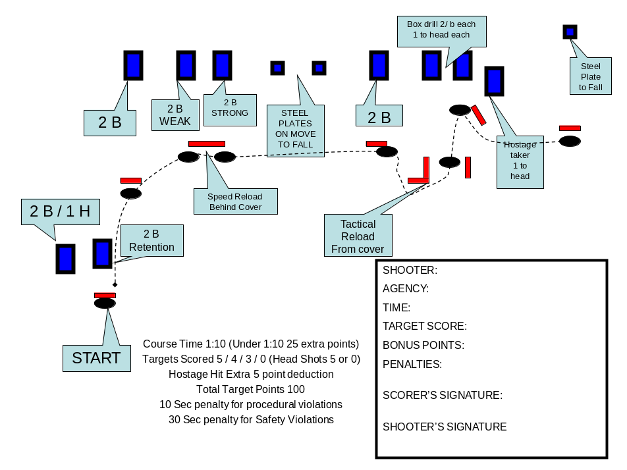

In this type of dynamic, one on one (Instructor Student ratio) live fire course, the Officer will have to make use of cover, fire from all positions, including shooting on the move, reloading and malfunction clearance if experienced during the course and allow for shot placement “scoring” and round accountability and decision making, as each target is only fired upon from one position, which allows the Instructor to identify areas which are in need of improvement. The same course could be used during low light training with their lighting systems.

